**Bigbasket website Clone**

**A MINI PROJECT REPORT**

SUBMITTED IN PARTIAL FULFILLMENT OF THE REQUIREMENTS FOR THE IN-HOUSE INTERNSHIP CUM TECHNICAL TRAINING

**Master of Computer Application**

**MCA**

**SUBMITTED TO**

**Dayananda Sagar College of Engineering**

**Department of MCA**

**SUBMITTED BY**

Rakesh GK (1DS21MC078)

Varun M (1DS21MC117)

Sam Manasseh (1DS21MC090)

**SUPERVISED BY**

Prof. Mahendra Kumar

Internal (MKB) and External (Shipla)

May 2023



**­­­**

**Dayananda Sagar College of Engineering,**

**Department of MCA, Bangalor**

**Bigbasket Clone System**

**A MINI PROJECT REPORT on Bigbasket**

SUBMITTED IN PARTIAL FULFILLMENT OF THE REQUIREMENTS FOR THE AWARD OF

**Master of Computer Application**

**SUBMITTED TO**

**Dayananda Sagar College of Engineering,**

**Department of MCA, Bangalore**

**SUBMITTED BY**

Rakesh GK (1DS21MC078)

Varun M (1DS21MC117)

Sam Manasseh (1DS21MC090)

**SUPERVISED BY**

Prof . Mahendra Kumar



**ACKNOWLEDGEMENT**

I would like to place on record my deep sense of gratitude to **DR. Smitha Khaiyum**, HOD-Dept. of MCA, Dayananda Sagar College of Engineering, India for his generous guidance, help and useful suggestions. Placement – Cell - Mr. GuruVenkatesh – VP – Placement & Training – Quality control. Mr. Rajeev Enhanced Knowledge Works, Bengaluru – Mrs/Ms. Shilpa – Corporate Trainer & Freelance Trainer. I express my sincere gratitude to Prof. Mahendra Kumar, Dept. of MCA, Dayananda Sagar College of Engineering India, for his stimulating guidance, continuous encouragement and supervision throughout the course of present work.

Rakesh GK

Varun M

Sam Manasseh

# CERTIFICATE

I hereby certify that the work which is being presented in the MCA, Mini Project Report entitled **“Bigbasket Clone System”,** in partial fulfillment of the requirements for the award of the In-House Internship cum Technical Trainingand submitted to the **Department of MCA, Dayananda Sagar College of Engineering, Bangalore** is an authentic record of my own work carried out during a period from **April 2023 to May 2023** (IV **semester**) under the supervision of **Prof. Mahendra Kumar,** **Department of MCA**.

The matter presented in this Project Report has not been submitted by me for the award of any other degree elsewhere.

**Rakesh GK**

**Varun M**

**Sam Manasseh**

This is to certify that the above statement made by the student(s) is correct to the best of my knowledge.

***Signature of Supervisor(s)***

**Prof. Mahendra Kumar Date : - 04 /May/2023**

**Signature**

**CONTENT**

|  |  |  |
| --- | --- | --- |
| **SL NO** | **PARTICULARS** | **PAGE NO** |
| **01** | Introduction of Bigbasket   * 1. Basic Introduction of Project   2. Objective and Scope   3. Project category | **07** |
| **02** | Tools and Technologies Used | **07** |
| **03** | Internet Information Server [ IIS ]  3.1 Features of IIS | **08** |
| **04** | System Analysis  4.1 Analysis & Information gathering  4.2 Hardware Interface  4.3 Software Interface  4.4 Communication Interface  4.5 Functional Requirements  4.6 Non-Functional Requirements | **09** |
| **05** | Screenshots  6.1 Login Page  6.2 Home Page  6.3 About Us  6.4 Safety  6.5 Help | **22** |
| **06**  **07**  **08**  **09**  **10** | Coding  Testing  Implementation  Conclusion and Future Enhancement  Reference | 27  35  38  38  40 |

**INTRODUCTION**

**Basic Introduction of Project**

Bigbasket is an E-commerce web application. E-commerce is fast gaining ground as an accepted and used business paradigm. More and more business houses are implementing websites providing functionality for performing commercial transactions over the web. It is reasonable to say that the process of shopping grocery on the web is becoming commonplace.

This project aims to develop a general-purpose e-commerce store where any grocery can be bought from the comfort of home through the Internet. However, this paper will deal with an online grocery shop for implementation purposes. The Big Basket is expanded permanently through new products and services in order to offer a product portfolio corresponding to the market. Private customers and business customers can order the selected grocery of the BigBasket service online quickly and comfortably.

**Objective and Scope**

The main objective of this application is to ease the purchase of groceries with ease of use with a web application.

**Project Category**

BigBasket is a web-based application. The web application is a software package that can be accessed through the web browser. In computing, a web application or web App is a client-server software application that the client (or user interface) runs in a web browser.

**Tools and Technologies used**

**Frontend**: HTML, CSS, BOOTSTRAP5 and Javascript.

**Internet Information Server [IIS]**

IIS server includes a broad range of administrative features for managing web sites and the web server. you can create and deploy scalable, flexible web applications.

**Features of IIS:**

Support of Internet standards:

The features include HTTP support and standard internet services such as:

* World Wide Web (WWW): It supports HTTP allowing users to publish content to the internet. Files can be placed in folders on our websites so that users can view them with a web browser. We can install business applications and publish them in HTML.
* File Transfer Protocol: It is an industry-standard protocol used for transferring files between computers on a TCP/IP network. FTP enables to use one computer to host multiple domain names.
* Simple Mail Transfer Protocol (SMTP): It is a standards-based, secure and scalable email server. It supports a distributed email server using SMTP and Post Office Protocol (POP3).

**SYSTEM ANALYSIS**

**Preliminary analysis & Information gathering**

**Preliminary analysis is defined as the initial process at the start of a project that determines whether the concept is viable.**It looks at economic, market, industry and social trends that influence the success of business endeavors associated with a proposed strategy. Preliminary analysis is repeated in situations where primary investigations trigger updates to plans.

Risk analysis and cost assessments are critical parts of the preliminary analysis phase. This gives leaders an idea of where the major concerns lie in a project. As it is impossible to rule out all problems in the project management life cycle, it is important to anticipate as many of these factors as possible with preliminary analytics.

**INFORMATION GATHERING**

It is the process of collecting information about something. Allow plenty of time for information gathering as well as for making necessary applications for financial support. Information gathering is carried out by surveying information about similar applications.

**Feasibility Study**

**Hardware Interface**

Processor : Intel i3, AMD 3 or higher

RAM : 4GB or higher

Hard Disk : 40GB or higher

Speed : 1.2 GHz or higher

**Software Interface**

Operating System : Windows 7 or Higher

IDE : Visual Studio

Language : HTML, CSS, Javascript

Framework : Bootstrap5

**Communication Interface**

## Bigbasket web application shall use the HTTP protocol for communication over the internet and for the internet communication will be through TCP/IP protocol suite.

## Functional Requirements

In software engineering and systems engineering, a functional requirement defines a function of a system or its component. A function is described as a set of inputs, behavior, and outputs. It should include descriptions of data to be entered into the system, operations performed by each system, workflow performed by the system and also how the system meets applicable regulatory requirements.

**Modules**

**Home**:

Whenever the user will open the site user must have to click on the Home module to view all the information about the services provided by Big Basket.

Users will get all the information on the Home page and they can get access to it and view all the services provided by Big Basket and also about ordering & detailed information related to groceries etc.

### About Us:

In this module, the user can gain more detailed information such as history, services, timings and nearest store address etc of the big basket.

### Login:

The user must create a new account or log in to an existing account to order the products on bigbasket.com. They can log in to the site either using an E-mail Id or Phone Number.

**Products:**

The customer can view different variety of products in a simplified manner according to their applied filters such as shops by cateogory, price, offers etc.

### Contact Us:

The user can Contact through this module by sharing their information and details in the given form to escalate and resolve any issues.

**Green BigBasket:**

This module will give an idea of the initiatives taken by Bigbasket towards environment and pollution control. It includes **Packaging-free Produce, Electric delivery vehicles etc.**

**Non-Functional Requirements**

**Performance requirements**

The system shall be based on the web that has to be run from the web server. The system shall take an initial load time depending on the internet connection strength which also depends on the media from which the system is run. The performance shall depend upon the hardware component of the client/customer

**Design Constraints**

The system shall be built using standard web page development too. The system must be stored in such a way that allows the client easy access to it. Response time for loading the system should take no longer than a few minutes

**CODING**

**1) index.html:**

<!DOCTYPE html>

<html lang="en">

<head>

    <meta charset="UTF-8">

    <meta http-equiv="X-UA-Compatible" content="IE=edge">

    <meta name="viewport" content="width=device-width, initial-scale=1.0">

    <link rel="stylesheet" href="style.css">

    <link href="https://cdn.jsdelivr.net/npm/bootstrap@5.3.0-alpha3/dist/css/bootstrap.min.css" rel="stylesheet" integrity="sha384-KK94CHFLLe+nY2dmCWGMq91rCGa5gtU4mk92HdvYe+M/SXH301p5ILy+dN9+nJOZ" crossorigin="anonymous">

    <script src="https://cdn.jsdelivr.net/npm/bootstrap@5.3.0-alpha3/dist/js/bootstrap.bundle.min.js" integrity="sha384-ENjdO4Dr2bkBIFxQpeoTz1HIcje39Wm4jDKdf19U8gI4ddQ3GYNS7NTKfAdVQSZe" crossorigin="anonymous"></script>

    <title>Online Grocery Shopping and Online Supermarket in India - Bigbasket</title>

    <link rel="stylesheet" href="https://cdnjs.cloudflare.com/ajax/libs/font-awesome/4.7.0/css/font-awesome.min.css">

  </head>

<body>

    <header>

      <div class="container top-head">

        <div><span><i class="fa fa-phone"></i></span> 1860 123 1000 </div>

        <div><span><i class="fa fa-map-marker"></i></span> 56004 Bangalore </div>

        <div><span><i class="fa fa-user"></i></span> <a href="login.html">Login/Sign Up</a> </div></div>

      <div class="container bottom-head p-2">

        <div class=""><img src="images/big basket logo.png" alt=""></div>

        <div class="search-bar"><form action="">

          <input type="text" placeholder="Search.." name="search">

          <button type="submit"><i class="fa fa-search"></i></button>

        </form></div>

        <div class="shopping-basket bg-secondary bg-opacity-50 p-2">

          <span><i class="fa fa-shopping-basket text-danger"></i></span><span class="basket-text-end"> My basket</span>

        </div>

      </div>

    </header>

    <div class="header-mob">

      <div class="row text-center fs-2 text-white">

        <div class="col-3"><i class="fa fa-bars"></i></div>

        <div class="col-3"><i class="fa fa-user"></i></div>

        <div class="col-3"><i class="fa fa-map-marker"></i></div>

        <div class="col-3"><i class="fa fa-shopping-cart"></i></div>

      </div>

      <div class="search-bar1"><form action="">

        <input type="text" placeholder="Search.." name="search">

        <button type="submit"><i class="fa fa-search"></i></button>

      </form></div>

    </div>

      <!--body image-->

      <div class="bg-img">

        <img src="images/2305152-bbpl-staples_460_Bangalore.webp" alt="">

      </div>

      <!-- Top stripe -->

      <div class="container scroll-side pt-4">

        <button type="button" class="btn "><img src="images/top-stripe/egg-meat.webp" alt=""></button>

        <button type="button" class="btn "><img src="images/top-stripe/neu-pass.webp" alt=""></button>

        <button type="button" class="btn "><img src="images/top-stripe/ayurveda.webp" alt=""></button>

        <button type="button" class="btn "><img src="images/top-stripe/buy-more.webp" alt=""></button>

        <button type="button" class="btn "><img src="images/top-stripe/week-deals.webp" alt=""></button>   <button type="button" class="btn "><img src="images/top-stripe/combo-store.webp" alt=""></button>

      </div>

      <!-- my-smart-basket-->

      <div class="container pt-4">

        <div class="heading mt-4 text-center">

            <h5>My Smart Basket</h5>

            <hr>

        </div>

        <div class="my-smart-basket">

        <div id="slider-container" class="slider">

          <div class="slide">

            <div onclick="load_product()">

              <div class="offer">GET 33% OFF <i class="fa fa-asterisk" style="color: red;"></i></div>

              <div class="img"><img src="images/capsi.webp" alt=""></div>

              <p class="t1">Fresho</p>

              <p class="t2">Onion (Loose)</p>

              <select name="weight-amt">

                <option value="">1 kg - Rs 68.00</option>

                <option value="">250 g - Rs 18.00</option>

                <option value="">500 g - Rs 34.00</option>

              </select>

              <div class="delivery-data">

                <p class="t1">MRP: <s> Rs 44.75</s><span class="rs"> Rs 34</span></p>

                <div class="delivery-time">

                  <i class="fa fa-truck"> </i>

                  <p class="t1"><span> Standard Delivery: Tomorrow <br>9:00AM - 1:30PM</span></p>

                </div>

                <div class="cart-btn">

                  <div><label>Qty</label><input type="text" value="1"></div>

                  <button type="button">ADD <span><i class="fa fa-shopping-basket"></i></span> </i></button>

                </div>

              </div>

            </div>

          </div>

         <script>

          function load_product(){

            window.location.href = "product.html";

          }

         </script>

          <div class="slide">

            <div>

              <div class="offer">GET 33% OFF <i class="fa fa-asterisk" style="color: red;"></i></div>

              <div class="img"><img src="images/tender.webp" alt=""></div>

              <p class="t1">Fresho</p>

              <p class="t2">Tender-coconut</p>

              <select name="weight-amt">

                <option value="">1 kg - Rs 68.00</option>

                <option value="">250 g - Rs 18.00</option>

                <option value="">500 g - Rs 34.00</option>

              </select>

              <div class="delivery-data">

                <p class="t1">MRP: <s> Rs 44.75</s><span class="rs"> Rs 34</span></p>

                <div class="delivery-time">

                  <i class="fa fa-truck"> </i>

                  <p class="t1"><span> Standard Delivery: Tomorrow <br>9:00AM - 1:30PM</span></p>

                </div>

                <div class="cart-btn">

                  <div><label>Qty</label><input type="text" value="1"></div>

                  <button type="button">ADD <span><i class="fa fa-shopping-basket"></i></span> </i></button>

                </div>

              </div>

            </div>

          </div>

          <div class="slide">

            <div>

              <div class="offer">GET 33% OFF <i class="fa fa-asterisk" style="color: red;"></i></div>

              <div class="img"><img src="images/egg.webp" alt=""></div>

              <p class="t1">Fresho</p>

              <p class="t2">Egg</p>

              <select name="weight-amt">

                <option value="">1 kg - Rs 68.00</option>

                <option value="">250 g - Rs 18.00</option>

                <option value="">500 g - Rs 34.00</option>

              </select>

              <div class="delivery-data">

                <p class="t1">MRP: <s> Rs 44.75</s><span class="rs"> Rs 34</span></p>

                <div class="delivery-time">

                  <i class="fa fa-truck"> </i>

                  <p class="t1"><span> Standard Delivery: Tomorrow <br>9:00AM - 1:30PM</span></p>

                </div>

                <div class="cart-btn">

                  <div><label>Qty</label><input type="text" value="1"></div>

                  <button type="button">ADD <span><i class="fa fa-shopping-basket"></i></span> </i></button>

                </div>

              </div>

            </div>

          </div>

          <div class="slide">

            <div>

              <div class="offer">GET 33% OFF <i class="fa fa-asterisk" style="color: red;"></i></div>

              <div class="img"><img src="images/cauliflower.webp" alt=""></div>

              <p class="t1">Fresho</p>

              <p class="t2">Cauliflower</p>

              <select name="weight-amt">

                <option value="">1 kg - Rs 68.00</option>

                <option value="">250 g - Rs 18.00</option>

                <option value="">500 g - Rs 34.00</option>

              </select>

              <div class="delivery-data">

                <p class="t1">MRP: <s> Rs 44.75</s><span class="rs"> Rs 34</span></p>

                <div class="delivery-time">

                  <i class="fa fa-truck"> </i>

                  <p class="t1"><span> Standard Delivery: Tomorrow <br>9:00AM - 1:30PM</span></p>

                </div>

                <div class="cart-btn">

                  <div><label>Qty</label><input type="text" value="1"></div>

                  <button type="button">ADD <span><i class="fa fa-shopping-basket"></i></span> </i></button>

                </div>

              </div>

            </div>

          </div>

          <div class="slide">

            <div>

              <div class="offer">GET 33% OFF <i class="fa fa-asterisk" style="color: red;"></i></div>

              <div class="img"><img src="images/sunflower.webp" alt=""></div>

              <p class="t1">Fresho</p>

              <p class="t2">Sunflower</p>

              <select name="weight-amt">

                <option value="">1 kg - Rs 68.00</option>

                <option value="">250 g - Rs 18.00</option>

                <option value="">500 g - Rs 34.00</option>

              </select>

              <div class="delivery-data">

                <p class="t1">MRP: <s> Rs 44.75</s><span class="rs"> Rs 34</span></p>

                <div class="delivery-time">

                  <i class="fa fa-truck"> </i>

                  <p class="t1"><span> Standard Delivery: Tomorrow <br>9:00AM - 1:30PM</span></p>

                </div>

                <div class="cart-btn">

                  <div><label>Qty</label><input type="text" value="1"></div>

                  <button type="button">ADD <span><i class="fa fa-shopping-basket"></i></span> </i></button>

                </div>

              </div>

            </div>

          </div>

          <div class="slide">

            <div>

              <div class="offer">GET 33% OFF <i class="fa fa-asterisk" style="color: red;"></i></div>

              <div class="img"><img src="images/ladies finger.webp" alt=""></div>

              <p class="t1">Fresho</p>

              <p class="t2">ladies finger</p>

              <select name="weight-amt">

                <option value="">1 kg - Rs 68.00</option>

                <option value="">250 g - Rs 18.00</option>

                <option value="">500 g - Rs 34.00</option>

              </select>

              <div class="delivery-data">

                <p class="t1">MRP: <s> Rs 44.75</s><span class="rs"> Rs 34</span></p>

                <div class="delivery-time">

                  <i class="fa fa-truck"> </i>

                  <p class="t1"><span> Standard Delivery: Tomorrow <br>9:00AM - 1:30PM</span></p>

                </div>

                <div class="cart-btn">

                  <div><label>Qty</label><input type="text" value="1"></div>

                  <button type="button">ADD <span><i class="fa fa-shopping-basket"></i></span> </i></button>

                </div>

              </div>

            </div>

          </div>

          <div class="slide">

            <div>

              <div class="offer">GET 33% OFF <i class="fa fa-asterisk" style="color: red;"></i></div>

              <div class="img"><img src="images/dove-soap.webp" alt=""></div>

              <p class="t1">Fresho</p>

              <p class="t2">Dove soap</p>

              <select name="weight-amt">

                <option value="">1 kg - Rs 68.00</option>

                <option value="">250 g - Rs 18.00</option>

                <option value="">500 g - Rs 34.00</option>

              </select>

              <div class="delivery-data">

                <p class="t1">MRP: <s> Rs 44.75</s><span class="rs"> Rs 34</span></p>

                <div class="delivery-time">

                  <i class="fa fa-truck"> </i>

                  <p class="t1"><span> Standard Delivery: Tomorrow <br>9:00AM - 1:30PM</span></p>

                </div>

                <div class="cart-btn">

                  <div><label>Qty</label><input type="text" value="1"></div>

                  <button type="button">ADD <span><i class="fa fa-shopping-basket"></i></span> </i></button>

                </div>

              </div>

            </div>

          </div>

         </div>

         <div onclick="prev()" class="control-prev-btn">

          &lt;

        </div>

        <div onclick="next()" class="control-next-btn">

          &gt

        </div>

      </div>

      <!--Bank offers-->

      <div class="container bank-offer ">

        <div class="heading mt-4 text-center">

            <h5>Bank offers</h5>

            <hr>

        </div>

        <div class="row">

            <div class="col-md-3">

                <img src="images/sbi.webp" alt="">

            </div>

            <div class="col-md-3">

                <img src="images/paytm.webp" alt="">

            </div>

            <div class="col-md-3">

                <img src="images/mobivik.webp" alt="">

            </div>

            <div class="col-md-3">

                <img src="images/freecharge.webp" alt="">

            </div>

        </div>

      </div>

      <!-- best-sellers-->

      <div class="container pt-4">

        <div class="heading mt-4 text-center">

            <h5>Best sellers</h5>

            <hr>

        </div>

        <div class="my-smart-basket">

        <div id="slider-container1" class="slider">

          <div class="slide">

            <div>

              <div class="offer">GET 33% OFF <i class="fa fa-asterisk" style="color: red;"></i></div>

              <div class="img"><img src="images/onion.webp" alt=""></div>

              <p class="t1">Fresho</p>

              <p class="t2">Onion (Loose)</p>

              <select name="weight-amt">

                <option value="">1 kg - Rs 68.00</option>

                <option value="">250 g - Rs 18.00</option>

                <option value="">500 g - Rs 34.00</option>

              </select>

              <div class="delivery-data">

                <p class="t1">MRP: <s> Rs 44.75</s><span class="rs"> Rs 34</span></p>

                <div class="delivery-time">

                  <i class="fa fa-truck"> </i>

                  <p class="t1"><span> Standard Delivery: Tomorrow <br>9:00AM - 1:30PM</span></p>

                </div>

                <div class="cart-btn">

                  <div><label>Qty</label><input type="text" value="1"></div>

                  <button type="button">ADD <span><i class="fa fa-shopping-basket"></i></span> </i></button>

                </div>

              </div>

            </div>

          </div>

          <div class="slide">

            <div>

              <div class="offer">GET 33% OFF <i class="fa fa-asterisk" style="color: red;"></i></div>

              <div class="img"><img src="images/tender.webp" alt=""></div>

              <p class="t1">Fresho</p>

              <p class="t2">Tender-coconut</p>

              <select name="weight-amt">

                <option value="">1 kg - Rs 68.00</option>

                <option value="">250 g - Rs 18.00</option>

                <option value="">500 g - Rs 34.00</option>

              </select>

              <div class="delivery-data">

                <p class="t1">MRP: <s> Rs 44.75</s><span class="rs"> Rs 34</span></p>

                <div class="delivery-time">

                  <i class="fa fa-truck"> </i>

                  <p class="t1"><span> Standard Delivery: Tomorrow <br>9:00AM - 1:30PM</span></p>

                </div>

                <div class="cart-btn">

                  <div><label>Qty</label><input type="text" value="1"></div>

                  <button type="button">ADD <span><i class="fa fa-shopping-basket"></i></span> </i></button>

                </div>

              </div>

            </div>

          </div>

          <div class="slide">

            <div>

              <div class="offer">GET 33% OFF <i class="fa fa-asterisk" style="color: red;"></i></div>

              <div class="img"><img src="images/egg.webp" alt=""></div>

              <p class="t1">Fresho</p>

              <p class="t2">Egg</p>

              <select name="weight-amt">

                <option value="">1 kg - Rs 68.00</option>

                <option value="">250 g - Rs 18.00</option>

                <option value="">500 g - Rs 34.00</option>

              </select>

              <div class="delivery-data">

                <p class="t1">MRP: <s> Rs 44.75</s><span class="rs"> Rs 34</span></p>

                <div class="delivery-time">

                  <i class="fa fa-truck"> </i>

                  <p class="t1"><span> Standard Delivery: Tomorrow <br>9:00AM - 1:30PM</span></p>

                </div>

                <div class="cart-btn">

                  <div><label>Qty</label><input type="text" value="1"></div>

                  <button type="button">ADD <span><i class="fa fa-shopping-basket"></i></span> </i></button>

                </div>

              </div>

            </div>

          </div>

          <div class="slide">

            <div>

              <div class="offer">GET 33% OFF <i class="fa fa-asterisk" style="color: red;"></i></div>

              <div class="img"><img src="images/cauliflower.webp" alt=""></div>

              <p class="t1">Fresho</p>

              <p class="t2">Cauliflower</p>

              <select name="weight-amt">

                <option value="">1 kg - Rs 68.00</option>

                <option value="">250 g - Rs 18.00</option>

                <option value="">500 g - Rs 34.00</option>

              </select>

              <div class="delivery-data">

                <p class="t1">MRP: <s> Rs 44.75</s><span class="rs"> Rs 34</span></p>

                <div class="delivery-time">

                  <i class="fa fa-truck"> </i>

                  <p class="t1"><span> Standard Delivery: Tomorrow <br>9:00AM - 1:30PM</span></p>

                </div>

                <div class="cart-btn">

                  <div><label>Qty</label><input type="text" value="1"></div>

                  <button type="button">ADD <span><i class="fa fa-shopping-basket"></i></span> </i></button>

                </div>

              </div>

            </div>

          </div>

          <div class="slide">

            <div>

              <div class="offer">GET 33% OFF <i class="fa fa-asterisk" style="color: red;"></i></div>

              <div class="img"><img src="images/sunflower.webp" alt=""></div>

              <p class="t1">Fresho</p>

              <p class="t2">Sunflower</p>

              <select name="weight-amt">

                <option value="">1 kg - Rs 68.00</option>

                <option value="">250 g - Rs 18.00</option>

                <option value="">500 g - Rs 34.00</option>

              </select>

              <div class="delivery-data">

                <p class="t1">MRP: <s> Rs 44.75</s><span class="rs"> Rs 34</span></p>

                <div class="delivery-time">

                  <i class="fa fa-truck"> </i>

                  <p class="t1"><span> Standard Delivery: Tomorrow <br>9:00AM - 1:30PM</span></p>

                </div>

                <div class="cart-btn">

                  <div><label>Qty</label><input type="text" value="1"></div>

                  <button type="button">ADD <span><i class="fa fa-shopping-basket"></i></span> </i></button>

                </div>

              </div>

            </div>

          </div>

          <div class="slide">

            <div>

              <div class="offer">GET 33% OFF <i class="fa fa-asterisk" style="color: red;"></i></div>

              <div class="img"><img src="images/ladies finger.webp" alt=""></div>

              <p class="t1">Fresho</p>

              <p class="t2">ladies finger</p>

              <select name="weight-amt">

                <option value="">1 kg - Rs 68.00</option>

                <option value="">250 g - Rs 18.00</option>

                <option value="">500 g - Rs 34.00</option>

              </select>

              <div class="delivery-data">

                <p class="t1">MRP: <s> Rs 44.75</s><span class="rs"> Rs 34</span></p>

                <div class="delivery-time">

                  <i class="fa fa-truck"> </i>

                  <p class="t1"><span> Standard Delivery: Tomorrow <br>9:00AM - 1:30PM</span></p>

                </div>

                <div class="cart-btn">

                  <div><label>Qty</label><input type="text" value="1"></div>

                  <button type="button">ADD <span><i class="fa fa-shopping-basket"></i></span> </i></button>

                </div>

              </div>

            </div>

          </div>

          <div class="slide">

            <div>

              <div class="offer">GET 33% OFF <i class="fa fa-asterisk" style="color: red;"></i></div>

              <div class="img"><img src="images/dove-soap.webp" alt=""></div>

              <p class="t1">Fresho</p>

              <p class="t2">Dove soap</p>

              <select name="weight-amt">

                <option value="">1 kg - Rs 68.00</option>

                <option value="">250 g - Rs 18.00</option>

                <option value="">500 g - Rs 34.00</option>

              </select>

              <div class="delivery-data">

                <p class="t1">MRP: <s> Rs 44.75</s><span class="rs"> Rs 34</span></p>

                <div class="delivery-time">

                  <i class="fa fa-truck"> </i>

                  <p class="t1"><span> Standard Delivery: Tomorrow <br>9:00AM - 1:30PM</span></p>

                </div>

                <div class="cart-btn">

                  <div><label>Qty</label><input type="text" value="1"></div>

                  <button type="button">ADD <span><i class="fa fa-shopping-basket"></i></span> </i></button>

                </div>

              </div>

            </div>

          </div>

         </div>

         <div onclick="prev1()" class="control-prev-btn">

          &lt;

        </div>

        <div onclick="next1()" class="control-next-btn">

          &gt

        </div>

      </div>

      </div>

      <!-- top offer -->

      <div class="container pt-4 top-offer">

        <div class="heading mt-4 text-center">

            <h5>Top offers</h5>

            <hr>

        </div>

        <div class="row">

          <div class="col-md-3 col-6 ">

            <img src="images/top-offer/top-offer-1.webp" alt="">

          </div>

          <div class="col-md-3 col-6 ">

            <img src="images/top-offer/top-offer-2.webp" alt="">

          </div>

          <div class="col-md-3 col-6 ">

            <img src="images/top-offer/top-offer-3.webp" alt="">

          </div>

          <div class="col-md-3 col-6 ">

            <img src="images/top-offer/top-offer-4.webp" alt="">

          </div>

        </div>

      </div>

       <!-- Fruits & Vegetables -->

       <div class="container pt-4 top-offer">

        <div class="heading mt-4 text-center">

            <h5>Fruits & Vegetables</h5>

            <hr>

        </div>

        <div class="row">

          <div class="col-md-3 col-6 ">

            <img src="images/fruits-veg/fruits-veg-1.webp" alt="">

          </div>

          <div class="col-md-3 col-6 ">

            <img src="images/fruits-veg/fruits-veg-2.webp" alt="">

          </div>

          <div class="col-md-3 col-6 ">

            <img src="images/fruits-veg/fruits-veg-3.webp" alt="">

          </div>

          <div class="col-md-3 col-6 ">

            <img src="images/fruits-veg/fruits-veg-4.webp" alt="">

          </div>

        </div>

      </div>

      <!-- Your Daily Staples-->

    <div class="container pt-4">

      <div class="heading mt-4 text-center">

          <h5>Your Daily Staples</h5>

          <hr>

          <div class="container brand-store">

            <img src="images/daily-sap/daily-sap-1.webp" alt="">

            <img src="images/daily-sap/daily-sap-2.webp" alt="">

            <img src="images/daily-sap/daily-sap-3.webp" alt="">

            <img src="images/daily-sap/daily-sap-4.webp" alt="">

            <img src="images/daily-sap/daily-sap-5.webp" alt="">

            <img src="images/daily-sap/daily-sap-6.webp" alt="">

          </div>

      </div>

      <!-- Brand Store -->

    <div class="container pt-4">

      <div class="heading mt-4 text-center">

          <h5>Brand Store</h5>

          <hr>

          <div class="container brand-store">

            <img src="images/amul.webp" alt="">

            <img src="images/detol.webp" alt="">

            <img src="images/coca-cola.webp" alt="">

            <img src="images/loreal.webp" alt="">

            <img src="images/india-gate.webp" alt="">

            <img src="images/durex.webp" alt="">

          </div>

      </div>

    <!-- featured recipe -->

    <div class="container pt-4">

      <div class="heading mt-4 text-center">

          <h5>Featured Recipes</h5>

          <hr>

          <img src="images/featured-recipe.webp" alt="" style="width: 100%;">

      </div>

      <div class="container mt-4">

      <div class="about p-4 border">

        <h3>bigbasket – online grocery store</h3>

        <p>Did you ever imagine that the freshest of <span class="text-success fw-bold">fruits and vegetables</span>, top quality pulses and food grains, <span class="text-success fw-bold">dairy products </span> and hundreds of branded items could be handpicked and delivered to your home, all at the click of a button? India’s first comprehensive online megastore, bigbasket.com, brings a whopping 20000+ products with more than 1000 brands, to over 4 million happy customers. From household cleaning products to beauty and makeup, bigbasket has everything you need for your daily needs. bigbasket.com is convenience personified We’ve taken away all the stress associated with shopping for daily essentials, and you can now order all your household products and even buy groceries online without travelling long distances or standing in serpentine queues. Add to this the convenience of finding all your requirements at one single source, along with great savings, and you will realize that bigbasket- India’s largest online supermarket, has revolutionized the way India shops for groceries. Online grocery shopping has never been easier. Need things fresh? Whether it’s fruits and vegetables or dairy and meat, we have this covered as well! Get fresh eggs, meat, fish and more online at your convenience. Hassle-free Home Delivery options</p>

        <p>We deliver to 25 cities across India and maintain excellent delivery times, ensuring that all your products from groceries to snacks <span class="text-success fw-bold">branded foods</span> reach you in time.</p>

        <ul>

            <li>Slotted Delivery: Pick the most convenient delivery slot to have your grocery delivered. From early morning delivery for early birds, to late-night delivery for people who work the late shift, bigbasket caters to every schedule.</li>

            <li>Express Delivery: This super useful service can be availed by customers in cities like Bangalore, Mumbai, Pune, Chennai, Kolkata, Hyderabad and Delhi-NCR in which we deliver your orders to your doorstep in 90 Minutes.</li>

            <li>BB Specialty stores: Missed out on buying that essential item from your favorite neighborhood store for tonight’s party? We’ll deliver it for you! From bakery, sweets and meat to flowers and chocolates, we deliver your order in 90 minutes, through a special arrangement with a nearby specialty store, verified by us.</li>

        </ul>

        <button type="button" class="btn btn-dark">read more</button>

      </div>

      <div class="row footer-cols">

        <div class="col-md-3">

          <p>big basket</p>

          <ul>

            <li><a href="about.html">About Us</a></li>

            <li><a href="#">In News</a></li>

            <li><a href="green_basket.html">Green bigbasket</a></li>

            <li><a href="#">Privacy Policy</a></li>

            <li><a href="#">Affliate</a></li>

            <li><a href="#">terms and Conditions</a></li>

            <li><a href="#">Careers At bigbasket</a></li>

            <li><a href="#">bb Instant</a></li>

            <li><a href="#">bb Daily</a></li>

            <li><a href="#">bb Blog</a></li>

            <li><a href="#">bbnow</a></li>

          </ul>

        </div>

        <div class="col-md-3">

          <p>Help</p>

          <ul>

            <li><a href="#">FAQs</a></li>

            <li><a href="contact.html">Contact Us</a></li>

            <li><a href="#">bb Wallet FAQs</a></li>

            <li><a href="#">bb Wallet T&Cs</a></li>

            <li><a href="#">Vendor Connect</a></li>

          </ul>

        </div>

        <div class="col-md-3">

          <p>Download Our Aap</p>

          <img src="images/store-icon.png" alt="" style="width: 50%;">

        </div>

        <div class="col-md-3">

          <p>Get Social With Us</p>

          <img src="images/social-media-icons.jpg" alt="" style="width: 100%;">

        </div>

      </div>

    </div>

    </div>

    <hr>

    <div class="container">

      <div class="row">

        <div class="col-md-2 text-success">POPULAR CATEGORIES:</div>

        <div class="col-md-10">

          Sunflower Oils, Wheat Atta, Ghee, Milk, Health Drinks, Flakes, Organic F&V, Namkeen, Eggs, Floor Cleaners, Other Juices, Leafy Vegetables, Frozen Veg Food, Diapers & Wipes,</div>

      </div>

      <div class="row">

        <div class="col-md-2 text-success">POPULAR BRANDS:</div>

        <div class="col-md-10">

          Amul, Nescafe , MTR, RED BULL , elite cake, Pediasure, Yummiez, Yera, Yakult, Britannia, Wow Momo, Fortune , Haldirams , Ferrero, Lays, Patanjali, McCain, kwality walls, Cadbury Dairy Milk, Pedigree,</div>

      </div>

      <div class="row">

        <div class="col-md-2 text-success">CITIES WE SERVE:</div>

        <div class="col-md-10">

          Bangalore, Hyderabad, Mumbai, Pune, Chennai, Delhi, Mysore, Madurai, Coimbatore, Vijayawada-Guntur, Kolkata, Ahmedabad-Gandhinagar, Nashik Business, Lucknow-Kanpur, Gurgaon, Vadodara, Visakhapatnam, Surat, Nagpur, Patna, Indore, Chandigarh Tricity, Jaipur, Bhopal, Noida-Ghaziabad, Kochi, Krishna District, Bhubaneshwar-Cuttack, Guwahati, Renigunta, Hubli, Davanagere, Trichy, Amravati, Raipur, Rajkot, Gwalior, Bareilly, Allahabad, Hyderabad Rural, Bangalore Rural, Chennai Rural, Vizag Rural, Lucknow Rural, Noida Rural, Ahmedabad Rural, Bhopal Rural, Bhubaneswar Rural, Coimbatore Rural, Chandigarh Rural, Gurugram Rural, Guwahati Rural, Indore Rural, Kochi Rural, Kolkata Rural, Mumbai Rural, Mysore Rural, Nagpur Rural, Patna Rural, Pune Rural, Surat Rural, Vadodara Rural, Jaipur Rural, Ranchi, Nashik, Agra, Kozhikode, Amritsar, </div>

      </div>

    </div>

    <div class="bg-light mt-4 p-2"><small><div class="container">Copyright © 2022-2024 Supermarket Grocery Supplies Pvt Ltd</div></small></div>

    <!-- jvascripts for slider -->

    <script>

      function prev(){

          document.getElementById('slider-container').scrollLeft -= 500;

      }

      function next()

      {

          document.getElementById('slider-container').scrollLeft += 500;

      }

    </script>

    <script>

      function prev1(){

          document.getElementById('slider-container1').scrollLeft -= 500;

      }

      function next1()

      {

          document.getElementById('slider-container1').scrollLeft += 500;

      }

    </script>

</body>

</html>

**2) product.html:**

<!DOCTYPE html>

<html lang="en">

<head>

    <meta charset="UTF-8">

    <meta http-equiv="X-UA-Compatible" content="IE=edge">

    <meta name="viewport" content="width=device-width, initial-scale=1.0">

    <title>Product</title>

    <link rel="stylesheet" href="style.css">

    <link href='https://fonts.googleapis.com/css?family=Poppins' rel='stylesheet'>

    <link rel="stylesheet" href="https://cdnjs.cloudflare.com/ajax/libs/font-awesome/4.7.0/css/font-awesome.min.css">

    <!-- Bootstrap 5 -->

    <link href="https://cdn.jsdelivr.net/npm/bootstrap@5.3.0-alpha3/dist/css/bootstrap.min.css" rel="stylesheet"

        integrity="sha384-KK94CHFLLe+nY2dmCWGMq91rCGa5gtU4mk92HdvYe+M/SXH301p5ILy+dN9+nJOZ" crossorigin="anonymous">

    <script src="https://cdn.jsdelivr.net/npm/bootstrap@5.3.0-alpha3/dist/js/bootstrap.bundle.min.js"

        integrity="sha384-ENjdO4Dr2bkBIFxQpeoTz1HIcje39Wm4jDKdf19U8gI4ddQ3GYNS7NTKfAdVQSZe"

        crossorigin="anonymous"></script>

        <link rel="stylesheet" href="https://cdnjs.cloudflare.com/ajax/libs/font-awesome/4.7.0/css/font-awesome.min.css">

</head>

<body>

    <header class="bg-white">

        <div class="container top-head">

          <div><span><i class="fa fa-phone"></i></span> 1860 123 1000 </div>

          <div><span><i class="fa fa-map-marker"></i></span> 56004 Bangalore </div>

          <div><span><i class="fa fa-user"></i></span> <a href="login.html">Login/Sign Up</a> </div>

        </div>

        <div class="container bottom-head p-2">

          <div class=""><a href="index.html"><img src="images/big basket logo.png" alt=""></a></div>

          <div class="search-bar"><form action="">

            <input type="text" placeholder="Search.." name="search">

            <button type="submit"><i class="fa fa-search"></i></button>

          </form></div>

          <div class="shopping-basket bg-secondary bg-opacity-50 p-2">

            <span><i class="fa fa-shopping-basket text-danger"></i></span><span class="basket-text-end"> My basket</span>

          </div>

        </div>

      </header>

      <div class="header-mob">

        <div class="row text-center fs-2 text-white">

          <div class="col-3"><i class="fa fa-bars"></i></div>

          <div class="col-3"><i class="fa fa-user"></i></div>

          <div class="col-3"><i class="fa fa-map-marker"></i></div>

          <div class="col-3"><i class="fa fa-shopping-cart"></i></div>

        </div>

        <div class="search-bar1"><form action="">

          <input type="text" placeholder="Search.." name="search">

          <button type="submit"><i class="fa fa-search"></i></button>

        </form></div>

      </div>

    <div class="container">

        <div class="row py-3">

            <div class="col-lg-6 py-2">

                <img src="images/p1.webp" alt="" id="main_img" class="float-end rounded img-fluid pb-2" width="430">

                <img src="images/p1.webp" onclick="changeImage1()" width="80" class="rounded mb-2 product_img" alt="">

                <img src="images/p2.webp" onclick="changeImage2()" width="80" class="rounded mb-2 product_img" alt="">

                <img src="images/p3.webp" onclick="changeImage3()" width="80" class="rounded mb-2 product_img" alt="">

                <img src="images/p4.webp" onclick="changeImage4()" width="80" class="rounded mb-2 product_img" alt="">

                <img src="images/p5.webp" onclick="changeImage5()" width="80" class="rounded mb-2 product_img" alt="">

            </div>

            <div class="col-lg-6 py-2">

                <h6 class="fw-bold">Fresho Capsicum - Green (Loose), <span id="gram_id">500 g</span></h6>

                <span class="text-secondary">MRP: &#8377;<s id="original_price_id">13.16</s></span><br>

                <h6>Price: &#8377;<span id="discount_price_id">10</span> <span class="text-secondary">(&#8377;<span id="per_gram_id">0.02 / g</span>)</span></h6>

                <span class="text-success">You Save: <span id="percentage_off_id">24</span>% OFF</span><br>

                <span class="text-secondary">(inclusive of all taxes)</span><br><br>

                <button class="btn btn-danger btn-lg mb-1">Add to basket</button>&emsp;

                <button class="btn btn-light btn-lg"><i class="fa fa-bookmark-o"></i> Save for later</button><br><br>

                <span class="text-secondary"><i class='fa fa-truck'></i> Standard: Get it in 1 day</span><br><br>

                <span class="fw-bold">Pack size</span><br>

                <div class="d-grid gap-2">

                    <button class="btn text-start" type="button" onclick="changepack1()" id="pack1">

                        <div class="row">

                            <div class="col">

                                <h6 id="gram_id1">500 g</h6>

                            </div>

                            <div class="col">

                                <h6>&#8377;<span id="discount_price_id">10</span> <span class="text-secondary">(&#8377;0.02 / g)</span></h6>

                                <s class="text-secondary">&#8377; 13.16</s>&emsp;<span

                                    class="bg-success text-success bg-opacity-25 px-2">24% OFF</span>

                            </div>

                        </div>

                    </button>

                    <button class="btn text-start" type="button" onclick="changepack2()" id="pack2">

                        <div class="row">

                            <div class="col">

                                <h6>250 g</h6>

                            </div>

                            <div class="col">

                                <h6>&#8377;5 <span class="text-secondary">(&#8377;0.02 / g)</span></h6>

                                <s class="text-secondary">&#8377; 6.58</s>&emsp;<span

                                    class="bg-success text-success bg-opacity-25 px-2">24% OFF</span>

                            </div>

                        </div>

                    </button>

                    <button class="btn text-start" type="button" onclick="changepack3()"  id="pack3">

                        <div class="row">

                            <div class="col">

                                <h6>1 kg</h6>

                            </div>

                            <div class="col">

                                <h6>&#8377;19.5 <span class="text-secondary">(&#8377;19.5 / kg)</span></h6>

                                <s class="text-secondary">&#8377; 26.32</s>&emsp;<span

                                    class="bg-success text-success bg-opacity-25 px-2">26% OFF</span>

                            </div>

                        </div>

                    </button>

                </div>

            </div>

        </div>

        <hr />

        <div class="text-center fw-bold mt-3">Why choose Bigbasket?</div>

        <div class="row py-2 ">

            <div class="col mb-1">

                <div class="card text-center bg-light">

                    <div class="card-body">

                        <i class="fa fa-thermometer-full rounded-circle bg-white py-3 px-4"

                            aria-hidden="true"></i><br><br>

                        <span class="fw-bold">Quality</span><br>

                        You can trust

                    </div>

                </div>

            </div>

            <div class="col mb-1">

                <div class="card text-center bg-light">

                    <div class="card-body">

                        <i class="fa fa-clock-o rounded-circle bg-white py-3 px-4" aria-hidden="true"></i><br><br>

                        <span class="fw-bold">On time</span><br>

                        Guarantee

                    </div>

                </div>

            </div>

            <div class="col">

                <div class="card text-center bg-light">

                    <div class="card-body">

                        <i class="fa fa-truck rounded-circle bg-white py-3 px-4" aria-hidden="true"></i><br><br>

                        <span class="fw-bold">Free</span><br>

                        Delivery

                    </div>

                </div>

            </div>

            <div class="col">

                <div class="card text-center bg-light">

                    <div class="card-body">

                        <i class="fa fa-trash-o rounded-circle bg-white py-3 px-4" aria-hidden="true"></i><br><br>

                        <span class="fw-bold">Return Policy</span><br>

                        No Question asked

                    </div>

                </div>

            </div>

        </div>

        <hr />

        <h6 class="fw-bold mt-5 mb-4">Fresho Capsicum - Green (Loose)</h6>

        <div class="rounded border border-secondary p-1">

            <div class="accordion mb-3">

                <div class="accordion-item">

                    <h2 class="accordion-header">

                        <h6 class="fw-bold pt-2 ps-4">About the Product</h6>

                        <button class="accordion-button about_accordion-button text_13 bg-white" type="button"

                            data-bs-toggle="collapse" data-bs-target="#collapseOne" aria-expanded="true"

                            aria-controls="collapseOne">

                            &emsp;&#183;&emsp;Leaving a moderately pungent taste on the tongue, Green capsicums, also

                            known as green peppers

                            are bell shaped, medium-sized fruit pods.<br>

                            &emsp;&#183;&emsp;They have thick and shiny skin with a fleshy texture inside.

                        </button>

                    </h2>

                    <div id="collapseOne" class="accordion-collapse collapse show">

                        <div class="accordion-body">

                            <h6 class="text_13">Do not forget to check our delicious recipe -</h6>

                            <a href="https://www.bigbasket.com/cookbook/recipes/2031/capsicum-cheese-rings/" class="text_13 text-decoration-none">

                            recipes/ 2031/capsicum-cheese-rings/</a>

                        </div>

                    </div>

                </div>

            </div>

            <hr/>

            <div class="pt-2 ps-4 text_13">

                <h6 class="fw-bold">Benefits</h6>

                &emsp;&#183;&emsp;Green capsicums have powerful antioxidants and anti-inflammatory properties.<br>

                &emsp;&#183;&emsp;Rich in Vitamin A, B complex, C and phytonutrients. Relieves pain of bone disorders and has the capacity to relax the repirartory passage.

            </div>

            <hr/>

            <div class="accordion mb-3">

                <div class="accordion-item">

                    <h2 class="accordion-header">

                        <h6 class="fw-bold pt-2 ps-4">Storage and Uses</h6>

                        <button class="accordion-button about_accordion-button text_13 bg-white" type="button"

                            data-bs-toggle="collapse" data-bs-target="#collapseTwo" aria-expanded="true"

                            aria-controls="collapseTwo">

                            &emsp;&#183;&emsp;Store them in a cool, dry place away from direct sunlight. Keep capsicums dry as moisture makes them rot faster. Refrigerate the peppers unwashed, in a plastic bag and consume within a week. Resort to refrigeration only when they cannot be consumed immediately.

                        </button>

                    </h2>

                    <div id="collapseTwo" class="accordion-collapse collapse">

                        <div class="accordion-body">

                            <h6 class="text_13">&emsp;&#183;&emsp;Green bell peppers can be used for a wide variety of dishes due to its distinct flavour and scent. Can be grilled,roasted, baked and sauteed. Widely used in salads, pastas, pizzas, pepper sauce and even for flavouring curries.</h6>

                        </div>

                    </div>

                </div>

            </div>

            <hr/>

            <div class="accordion mb-3">

                <div class="accordion-item">

                    <h2 class="accordion-header">

                        <h6 class="fw-bold pt-2 ps-4">Other Product Info</h6>

                        <button class="accordion-button about_accordion-button text_13 bg-white" type="button"

                            data-bs-toggle="collapse" data-bs-target="#collapseThree" aria-expanded="true"

                            aria-controls="collapseThree">

                            EAN Code: 6900001<br>

                            Sourced & Marketed by: Supermarket Grocery Supplies Pvt. Ltd, No. 7, Service Road, Off 100 Feet Road Indiranagar Landmark: Above HDFC Bank Bangalore, Karnataka 560071

                        </button>

                    </h2>

                    <div id="collapseThree" class="accordion-collapse collapse">

                        <div class="accordion-body">

                            <h6 class="text_13">Country of Origin: India<br>

                                Best before 3 days from delivery date<br>

                                For Queries/Feedback/Complaints, Contact our Customer Care Executive at: Phone: 1860 123 1000 | Address: Innovative Retail Concepts Private Limited, No.18, 2nd & 3rd Floor, 80 Feet Main Road, Koramangala 4th Block, Bangalore - 560034 | Email: customerservice@bigbasket.com</h6>

                        </div>

                    </div>

                </div>

            </div>

        </div>

        <h6 class="fw-bold mt-5">Rating and Reviews</h6>

        <div class="text-center rounded border border-secondary">

            <img src="images/rating.png" alt="" width="400">

        </div>

        <div class="bg-light rounded p-4 mt-5">

            <h6 class="fw-bold">Frequently Bought Together</h6>

            <hr/>

            <h6 class="fw-bold mt-4">Similar Products</h6>

        </div>

        <div class="text-center m-5">

            <h6 class="fw-bold">You may like to view more in</h6>

            <button class="btn border border-dark rounded-pill px-3 mb-1">COUNTRY OF ORIGIN : India ></button>&emsp;

            <button class="btn border border-dark rounded-pill px-3">FOOD PREFERENCE : Vegetarian ></button>

        </div>

        <h6 class="fw-bold">Recipes</h6>

        <div class="text_13 mb-3">Have a look at what you can make with this item</div>

        <div class="row text-center">

            <div class="col mb-3">

                <div class="card" style="width: 25rem;">

                    <img src="images/recipe1.webp" class="card-img-top mb-1" alt="...">

                    <div class="card-body">

                        <p class="card-text">Cheesy Potato Lollipops</p>

                    </div>

                </div>

            </div>

            <div class="col mb-3">

                <div class="card " style="width: 25rem;">

                    <img src="images/recipe2.webp" class="card-img-top mb-1" alt="...">

                    <div class="card-body">

                        <p class="card-text">Paneer Capsicum Fry</p>

                    </div>

                </div>

            </div>

            <div class="col mb-3">

                <div class="card" style="width: 25rem;">

                    <img src="images/recipe3.webp" class="card-img-top mb-1" alt="...">

                    <div class="card-body">

                        <p class="card-text">Pav Bhaji Masala Omelette</p>

                    </div>

                </div>

            </div>

        </div>

        <h6 class="fw-bold mt-5">More Information</h6>

        <span class="text_13 fw-bold">Fruits & Vegetables > Fresh Vegetables</span><br>

        <span class="text_13">Beans, Brinjals & Okra | Cabbage & Cauliflower | Cucumber & Capsicum | Gourd, Pumpkin, Drumstick | Leafy Vegetables | Potato, Onion & Tomato | Root Vegetables | Specialty</span><br><br>

        <h6 class="fw-bold">Brands</h6>

        <div class="text_13 mb-5">Fresho | Fresho Cucumber & Capsicum</div>

    </div>

    <div class="container mt-4">

        <div class="row footer-cols">

          <div class="col-md-3">

            <p>big basket</p>

            <ul>

              <li><a href="about.html">About Us</a></li>

              <li><a href="#">In News</a></li>

              <li><a href="green_basket.html">Green bigbasket</a></li>

              <li><a href="#">Privacy Policy</a></li>

              <li><a href="#">Affliate</a></li>

              <li><a href="#">terms and Conditions</a></li>

              <li><a href="#">Careers At bigbasket</a></li>

              <li><a href="#">bb Instant</a></li>

              <li><a href="#">bb Daily</a></li>

              <li><a href="#">bb Blog</a></li>

              <li><a href="#">bbnow</a></li>

            </ul>

          </div>

          <div class="col-md-3">

            <p>Help</p>

            <ul>

              <li><a href="#">FAQs</a></li>

              <li><a href="contact.html">Contact Us</a></li>

              <li><a href="#">bb Wallet FAQs</a></li>

              <li><a href="#">bb Wallet T&Cs</a></li>

              <li><a href="#">Vendor Connect</a></li>

            </ul>

          </div>

          <div class="col-md-3">

            <p>Download Our Aap</p>

            <img src="images/store-icon.png" alt="" style="width: 50%;">

          </div>

          <div class="col-md-3">

            <p>Get Social With Us</p>

            <img src="images/social-media-icons.jpg" alt="" style="width: 100%;">

          </div>

        </div>

      </div>

      </div>

      <hr>

      <div class="container">

        <div class="row">

          <div class="col-md-2 text-success">POPULAR CATEGORIES:</div>

          <div class="col-md-10">

            Sunflower Oils, Wheat Atta, Ghee, Milk, Health Drinks, Flakes, Organic F&V, Namkeen, Eggs, Floor Cleaners, Other Juices, Leafy Vegetables, Frozen Veg Food, Diapers & Wipes,</div>

        </div>

        <div class="row">

          <div class="col-md-2 text-success">POPULAR BRANDS:</div>

          <div class="col-md-10">

            Amul, Nescafe , MTR, RED BULL , elite cake, Pediasure, Yummiez, Yera, Yakult, Britannia, Wow Momo, Fortune , Haldirams , Ferrero, Lays, Patanjali, McCain, kwality walls, Cadbury Dairy Milk, Pedigree,</div>

        </div>

        <div class="row">

          <div class="col-md-2 text-success">CITIES WE SERVE:</div>

          <div class="col-md-10">

            Bangalore, Hyderabad, Mumbai, Pune, Chennai, Delhi, Mysore, Madurai, Coimbatore, Vijayawada-Guntur, Kolkata, Ahmedabad-Gandhinagar, Nashik Business, Lucknow-Kanpur, Gurgaon, Vadodara, Visakhapatnam, Surat, Nagpur, Patna, Indore, Chandigarh Tricity, Jaipur, Bhopal, Noida-Ghaziabad, Kochi, Krishna District, Bhubaneshwar-Cuttack, Guwahati, Renigunta, Hubli, Davanagere, Trichy, Amravati, Raipur, Rajkot, Gwalior, Bareilly, Allahabad, Hyderabad Rural, Bangalore Rural, Chennai Rural, Vizag Rural, Lucknow Rural, Noida Rural, Ahmedabad Rural, Bhopal Rural, Bhubaneswar Rural, Coimbatore Rural, Chandigarh Rural, Gurugram Rural, Guwahati Rural, Indore Rural, Kochi Rural, Kolkata Rural, Mumbai Rural, Mysore Rural, Nagpur Rural, Patna Rural, Pune Rural, Surat Rural, Vadodara Rural, Jaipur Rural, Ranchi, Nashik, Agra, Kozhikode, Amritsar, </div>

        </div>

      </div>

      <div class="bg-light mt-4 p-2"><small><div class="container">Copyright © 2022-2024 Supermarket Grocery Supplies Pvt Ltd</div></small></div>

    <script>

        var main_img=document.getElementById("main_img");

        function changeImage1()

        {

            main_img.src = 'images/p1.webp';

        }

        function changeImage2()

        {

            main_img.src = 'images/p2.webp';

        }

        function changeImage3()

        {

            main_img.src = 'images/p3.webp';

        }

        function changeImage4()

        {

            main_img.src = 'images/p4.webp';

        }

        function changeImage5()

        {

            main_img.src = 'images/p5.webp';

        }

        var gram=document.getElementById("gram_id");

        var per_gram=document.getElementById("per_gram_id");

        var original_price=document.getElementById("original_price_id");

        var discount_price=document.getElementById("discount_price_id");

        var percentage_off=document.getElementById("percentage_off_id");

        var pack1=document.getElementById("pack1");

        var pack2=document.getElementById("pack2");

        var pack3=document.getElementById("pack3");

        function changepack1()

        {

            pack1.style.borderColor="green";

            pack2.style.borderColor="black";

            pack3.style.borderColor="black";

            gram.innerHTML="500 g";

            per_gram.innerHTML="0.02 / g";

            original_price.innerHTML="13.16";

            discount_price.innerHTML="10";

            percentage_off.innerHTML="24";

        }

        function changepack2()

        {

            pack2.style.borderColor="green";

            pack1.style.borderColor="black";

            pack3.style.borderColor="black";

            gram.innerHTML="250 g";

            per_gram.innerHTML="0.02 / g";

            original_price.innerHTML="6.58";

            discount_price.innerHTML="5";

            percentage_off.innerHTML="24";

        }

        function changepack3()

        {

            pack3.style.borderColor="green";

            pack1.style.borderColor="black";

            pack2.style.borderColor="black";

            gram.innerHTML="1 kg";

            per_gram.innerHTML="19.5 / kg";

            original_price.innerHTML="26.32";

            discount_price.innerHTML="19.5";

            percentage_off.innerHTML="26";

        }

    </script>

</body>

</html>

**3) greenbasket.html:**

<!DOCTYPE html>

<html lang="en">

<head>

    <meta charset="UTF-8">

    <meta http-equiv="X-UA-Compatible" content="IE=edge">

    <meta name="viewport" content="width=device-width, initial-scale=1.0">

    <title>Green basket</title>

    <link rel="stylesheet" href="style.css">

    <link href='https://fonts.googleapis.com/css?family=Poppins' rel='stylesheet'>

    <link rel="stylesheet" href="https://cdnjs.cloudflare.com/ajax/libs/font-awesome/4.7.0/css/font-awesome.min.css">

    <!-- Bootstrap 5 -->

    <link href="https://cdn.jsdelivr.net/npm/bootstrap@5.3.0-alpha3/dist/css/bootstrap.min.css" rel="stylesheet"

        integrity="sha384-KK94CHFLLe+nY2dmCWGMq91rCGa5gtU4mk92HdvYe+M/SXH301p5ILy+dN9+nJOZ" crossorigin="anonymous">

    <script src="https://cdn.jsdelivr.net/npm/bootstrap@5.3.0-alpha3/dist/js/bootstrap.bundle.min.js"

        integrity="sha384-ENjdO4Dr2bkBIFxQpeoTz1HIcje39Wm4jDKdf19U8gI4ddQ3GYNS7NTKfAdVQSZe"

        crossorigin="anonymous"></script>

        <link rel="stylesheet" href="https://cdnjs.cloudflare.com/ajax/libs/font-awesome/4.7.0/css/font-awesome.min.css">

    <style>

        @media (max-width:440px) {

            *{

                font-size:10px;

            }

        }

    </style>

</head>

<body class="bg-light">

    <header class="bg-white">

        <div class="container top-head">

          <div><span><i class="fa fa-phone"></i></span> 1860 123 1000 </div>

          <div><span><i class="fa fa-map-marker"></i></span> 56004 Bangalore </div>

          <div><span><i class="fa fa-user"></i></span> <a href="login.html">Login/Sign Up</a> </div>

        </div>

        <div class="container bottom-head p-2">

          <div class=""><a href="index.html"><img src="images/big basket logo.png" alt=""></a></div>

          <div class="search-bar"><form action="">

            <input type="text" placeholder="Search.." name="search">

            <button type="submit"><i class="fa fa-search"></i></button>

          </form></div>

          <div class="shopping-basket bg-secondary bg-opacity-50 p-2">

            <span><i class="fa fa-shopping-basket text-danger"></i></span><span class="basket-text-end"> My basket</span>

          </div>

        </div>

      </header>

      <div class="header-mob">

        <div class="row text-center fs-2 text-white">

          <div class="col-3"><i class="fa fa-bars"></i></div>

          <div class="col-3"><i class="fa fa-user"></i></div>

          <div class="col-3"><i class="fa fa-map-marker"></i></div>

          <div class="col-3"><i class="fa fa-shopping-cart"></i></div>

        </div>

        <div class="search-bar1"><form action="">

          <input type="text" placeholder="Search.." name="search">

          <button type="submit"><i class="fa fa-search"></i></button>

        </form></div>

      </div>

    <div class="container bg-white my-2">

        &nbsp;

        <div class="border border-secondary mx-5 my-3 py-3 px-4">

            <img src="images/g1.webp" alt="..." class="img-fluid green_basket_img"><br>

            <img src="images/g2.webp" alt="..." class="img-fluid green_basket_img"><br><br>

            <span class="text-start">Dear bigbasketeer,<br><br>

                Sustainability is a subject that is close to our hearts. Since our inception in 2011, we've been trying

                to reduce our environmental footprint by making greener decisions.<br><br>

            </span>

            <img src="images/g3.webp" alt="..." class="img-fluid mx-auto d-block rounded"><br><br>

            Today, we want to share some of the green milestones we hit in 2021. By choosing us again and again for your

            grocery & home needs, you have helped us achieve these numbers. Thank you, we couldn't have done it without

            you!<br><br>

            <b>6 Key Initiatives</b><br><br>

            <div class="row mb-3">

                <div class="col-lg-4 mb-1"><img src="images/g41.webp" alt="..." class="img-fluid rounded"></div>

                <div class="col-lg-4 mb-1"><img src="images/g42.webp" alt="..." class="img-fluid rounded"></div>

                <div class="col-lg-4"><img src="images/g43.webp" alt="..." class="img-fluid rounded"></div>

            </div>

            <div class="row">

                <div class="col-lg-4 mb-1"><img src="images/g44.webp" alt="..." class="img-fluid rounded"></div>

                <div class="col-lg-4 mb-1"><img src="images/g45.webp" alt="..." class="img-fluid rounded"></div>

                <div class="col-lg-4"><img src="images/g46.webp" alt="..." class="img-fluid rounded"></div>

            </div>

            <br>

            <hr / class="text-success">

            <br>

            <div class="row">

                <div class="col-sm-1 bg-info bg-opacity-50 fw-bold rounded text-center py-4 mx-2 mb-1">#1</div>

                <div class="col-sm-10 bg-info bg-opacity-25 fw-bold rounded py-4">Electric Delivery Vehicles</div>

            </div><br>

            <div class="row">

                <div class="col-lg-3 text-info fs-4 fw-bold">

                    3,637 tonnes of CO2 saved by our fleet of 2,234 electric delivery vehicles

                </div>

                <div class="col-lg-6">

                    <img src="images/g5.webp" alt="..." class="img-fluid green_basket_img">

                </div>

            </div><br>

            We launched our first EVs back in 2016, long before they became a buzzword, with a pilot of 10 electric

            delivery vans in Noida. Many trials and challenges later, our fleet today has <b>1,623 electric bikes and

                611

                electric vans.</b> We’ve enabled 70 delivery hubs across 6 Tier-1 cities with ~939 EV charging

            facilities.

            <b>Today, EVs form 30%+ of our delivery fleet</b> and our goal is to hit 70% before the end of 2024. <b>In

                2021, we

                had the highest number of electric delivery vehicles</b> among all Indian ecommerce players.<br><br>

            <div class="bg-info bg-opacity-25 rounded">

                <div class="row">

                    <div class="col-lg-5 p-5">

                        <b>Why are EVs better?</b><br><br>

                        Petrol and diesel vehicles emit CO2, which is a ‘greenhouse gas’ that causes air pollution and

                        leads to global warming. Trees, by taking in CO2 for photosynthesis, mitigate this effect.

                        However, 1 tree can digest just 22kgs of CO2 in a year!

                    </div>

                    <div class="col-lg-5 p-5">

                        <img src="images/g7.webp" alt="..." class="img-fluid green_basket_img">

                    </div>

                </div>

                <div class="row">

                    <div class="col-lg-5 p-5">

                        <img src="images/g8.png" alt="..." class="img-fluid green_basket_img">

                    </div>

                    <div class="col-lg-5 p-5">

                        By using electric vehicles, we have reduced CO2 production by <b>3,637</b> tonnes in 2021 alone,

                        which

                        would have required <b>1,323</b> acres of greenery or <b>1,50,822</b> trees to neutralise. That

                        is a <b>green

                            space 4.4x the size of Cubbon Park or 14.9x of Lodhi Garden.</b>

                    </div>

                </div>

            </div><br>

            <div class="text-center">Read more <a href="">here</a></div><br>

            <hr / class="text-success"><br>

            <div class="row">

                <div class="col-sm-1 bg-success bg-opacity-50 fw-bold rounded text-center py-4 mx-2 mb-1">#2</div>

                <div class="col-sm-10 bg-success bg-opacity-25 fw-bold rounded py-4">Packaging-free Produce</div>

            </div>

            <div class="row">

                <div class="col-lg-5 p-5">

                    <b class="text-success fs-4 fw-bold">42% of fresh produce delivered packaging-free</b>

                </div>

                <div class="col-lg-5 p-5">

                    <img src="images/g9.webp" alt="..." class="img-fluid green_basket_img">

                </div>

            </div>

            Tonnes of packaging waste ends up in landfills every year, damaging soil quality. For years, we have been

            reducing our footprint here by minimising packaging, substituting more eco-friendly materials, and now,

            doing away with it altogether.<br><br>

            <div class="row">

                <div class="col-sm-1 bg-success bg-opacity-50 fw-bold rounded text-center py-4 mx-2 mb-1">2011</div>

                <div class="col-sm-10 bg-success bg-opacity-25 fw-bold rounded py-4">Bring deliveries in reusable

                    crates, not disposable bags, thus reducing waste.</div>

            </div><br>

            <div class="row">

                <div class="col-sm-1 bg-success bg-opacity-50 fw-bold rounded text-center py-4 mx-2 mb-1">2015</div>

                <div class="col-sm-10 bg-success bg-opacity-25 fw-bold rounded py-4">Replaced plastic bags with

                    compostable cornstarch bags.</div>

            </div><br>

            <div class="row">

                <div class="col-sm-1 bg-success bg-opacity-50 fw-bold rounded text-center py-4 mx-2 mb-1">2017</div>

                <div class="col-sm-10 bg-success bg-opacity-25 fw-bold rounded py-4">Reduced packaging and moved 90% to

                    paper bags as wherever possible.</div>

            </div><br>

            <div class="row">

                <div class="col-sm-1 bg-success bg-opacity-50 fw-bold rounded text-center py-4 mx-2 mb-1">2021</div>

                <div class="col-sm-10 bg-success bg-opacity-25 fw-bold rounded py-4">Launched pilot of 100%

                    packaging-free delivery of fruits & vegetables.</div>

            </div><br>

            <div class="row">

                <div class="col-sm-1 bg-success bg-opacity-50 fw-bold rounded text-center py-4 mx-2 mb-1">2023</div>

                <div class="col-sm-10 bg-success bg-opacity-25 fw-bold rounded py-4">Our goal is to switch to zero

                    packaging for fruits & veggies pan India by 2023.</div>

            </div><br>

            In spite of Covid-related delays, our pilot for this was rolled out successfully with delivery partners

            bringing fruits and vegetables in reusable carry bags and transferring them to customers’ storage bags.

            Thanks to you for welcoming this move wholeheartedly in spite of the slight extra effort involved! We plan

            to roll this out pan-India by 2023.<br><br>

            <hr / class="text-success"><br>

            <div class="row">

                <div class="col-sm-1 bg-warning bg-opacity-50 fw-bold rounded text-center py-4 mx-2 mb-1">#3</div>

                <div class="col-sm-10 bg-warning bg-opacity-25 fw-bold rounded py-4">Solar Powered Warehouses</div>

            </div>

            <div class="row">

                <div class="col-lg-5 p-5">

                    <b class="text-warning fs-4 fw-bold">36,94,089 kWp of solar power generated in 2021 alone</b>

                </div>

                <div class="col-lg-5 p-5">

                    <img src="images/g10.webp" alt="..." class="img-fluid green_basket_img">

                </div>

            </div>

            Solar power has vast potential in a sunny country like India. We started tapping it for our warehouse needs

            as far back as 2016, with solar panels installed on the roof of one of our Bangalore delivery

            centres.<br><br>

            Today, we have <b>4,363kWp</b> panels installed atop 28 warehouses in 9 cities. Together, these generated

            36,94,089kWp in 2021 alone, reducing our <b>CO2 emissions by 1,290 tonnes.</b> For perspective, this is the

            daily

            power consumed by 4.5 lakh+ households (8 kWh/day) in India. Many of our warehouses also <b>turned

                energy-positive, giving 3,51,807 kilowatt hours of power back to the grid in 2021.</b><br><br>

            <img src="images/g11.png" alt="..." class="img-fluid green_basket_img"><br><br>

            <hr / class="text-success"><br>

            <div class="row">

                <div class="col-sm-1 bg-danger bg-opacity-50 fw-bold rounded text-center py-4 mx-2 mb-1">#4</div>

                <div class="col-sm-10 bg-danger bg-opacity-25 fw-bold rounded py-4">Biomass Powered Refrigeration</div>

            </div>

            <div class="row">

                <div class="col-lg-5 p-5">

                    <b class="text-danger fs-4 fw-bold">90% reduction in electricity consumption through biomass-fuelled

                        cooling</b>

                </div>

                <div class="col-lg-5 p-5">

                    <img src="images/g12.webp" alt="..." class="img-fluid green_basket_img">

                </div>

            </div>

            Fruits, vegetables, dairy, meat… to keep these perishables fresh for you, we need cold rooms for storage.

            Unfortunately, conventional cooling systems not only run on fossil fuels and emit greenhouse gases but are

            also energy inefficient.<br><br>

            To find a solution, we partnered with the World Bank’s TechEmerge program that connects organisations with

            innovators. And on 1st January 2021, we installed <b>GreenCHILL, our first biomass-fueled chilling

                system</b>, in

            Bangalore, in partnership with New Leaf Dynamic Technologies.<br><br>

            When any natural plant-based material dies and decays, it releases CO2 back into the atmosphere. GreenCHILL

            uses this biomass to generate power. <b>These energy-efficient coolers use biowaste</b> such as cashew

            shells and

            coconut husk as fuel and <b>consume just 8 units/day of electricity</b> compared to the 90 units/day that a

            conventional cooling system uses. So far, we’ve established 9 GreenCHILL units, saving <b>186 tonnes of CO2

                per

                year!</b><br><br>

            <div class="row">

                <div class="col-lg-6 mb-1">

                    <img src="images/g131.png" alt="..." class="img-fluid green_basket_img">

                </div>

                <div class="col-lg-6">

                    <img src="images/g132.png" alt="..." class="img-fluid green_basket_img">

                </div>

            </div>

            <div class="text-center">Read more <a href="">here</a></div><br>

            <hr / class="text-success">

            <div class="row">

                <div class="col-lg-5">

                    <img src="images/g14.webp" alt="..." class="img-fluid green_basket_img">

                </div>

                <div class="col-lg-5">

                    <b class="fs-4 fw-bold">DID YOU KNOW?</b><br><br>

                    Our collection centres and cold rooms are located close in proximity. This way, food can be

                    transported quickly, reducing perishable food wastage.

                </div>

            </div>

            <hr / class="text-success"><br><br>

            <div class="row">

                <div class="col-sm-1 bg-primary bg-opacity-50 fw-bold rounded text-center py-4 mx-2 mb-1">#5</div>

                <div class="col-sm-10 bg-primary bg-opacity-25 fw-bold rounded py-4">Organic Farmer Partnerships</div>

            </div>

            <div class="row">

                <div class="col-lg-5 p-5">

                    <b class="text-primary fs-4 fw-bold">Long-term partnerships with 1200+ organic farmers</b>

                </div>

                <div class="col-lg-5 p-5">

                    <img src="images/g15.webp" alt="..." class="img-fluid green_basket_img">

                </div>

            </div>

            Prolonged use of chemicals strips soil of its fertility, whereas organic farming is gentler and more

            sustainable. Our vision is to go 100% organic in the next few years and we've developed long-term

            relationships with thousands of farmers who share our commitment.<br><br>

            We support them through initiatives such as field geotagging, offering agri intelligence on weather, soil &

            growing conditions, and organizing knowledge sessions on the latest farming techniques, government schemes,

            and more. We've been <b>awarded multiple times at Jaivik India for our direct farmer linkages.</b><br><br>

            <div class="row">

                <div class="col-lg-4 mb-1">

                    <img src="images/g16_1.webp" alt="..." class="img-fluid green_basket_img">

                </div>

                <div class="col-lg-4 mb-1">

                    <img src="images/g16_2.webp" alt="..." class="img-fluid green_basket_img">

                </div>

                <div class="col-lg-4">

                    <img src="images/g16_3.webp" alt="..." class="img-fluid green_basket_img">

                </div>

            </div><br>

            <div class="text-center">Want to know your kisaan?<br><br>Watch our video interview series <a

                    href="">here</a></div><br>

            <hr / class="text-success">

            <div class="row">

                <div class="col-lg-5">

                    <img src="images/g14.webp" alt="..." class="img-fluid green_basket_img">

                </div>

                <div class="col-lg-5">

                    <b class="fs-4 fw-bold">DID YOU KNOW?</b><br><br>

                    We have a large collection of eco-friendly home care products including floor cleaners, laundry

                    wash, and dishwash. These are gentle on you and on the planet too. See the range <a

                        href="">here.</a>

                </div>

            </div>

            <hr / class="text-success"><br><br>

            <div class="row">

                <div class="col-sm-1 bg-success bg-opacity-75 fw-bold rounded text-center py-4 mx-2 mb-1">#6</div>

                <div class="col-sm-10 bg-success bg-opacity-50 fw-bold rounded py-4">Rainwater Harvesting</div>

            </div>

            <div class="row">

                <div class="col-lg-5 p-5">

                    <b class="text-success fs-4 fw-bold">3,90,000 litres of rainwater harvested per year</b>

                </div>

                <div class="col-lg-5 p-5">

                    <img src="images/g17.webp" alt="..." class="img-fluid green_basket_img">

                </div>

            </div><br>

            Rainwater that goes uncollected is, at best, wasted, and at worst, a cause for flooding in congested cities.

            We have established rainwater harvesting systems of different capacities in 9 of our warehouses located in

            areas that receive good rainfall through the year.. On average, just 1 hour of rainfall lets us collect

            27,000 litres of water, which is sufficient to support the needs of one warehouse for over 5 days!<br>

            <hr / class="text-success"><br>

            <div class="text-center fw-bold">Going greener, one step at time</div><br>

            There is a beautiful saying in sustainability circles — real change happens not when a hundred people are

            perfectly sustainable but when a million of us attempt to be sustainable, however imperfectly. Thank you for

            always supporting us!<br><br>

            As we continue on this green journey, we promise you one thing: an unwavering commitment to move the needle

            on sustainability. We will keep trying, learning, and doing better every year.<br><br>

            <div class="text-center">

                <button class="btn btn-success btn-lg">Share Your Thoughts</button><br><br>

                Much love,<br>

                <b>All of us at bigbasket</b>

            </div>

        </div>

        &nbsp;

    </div>

    <div class="container mt-4">

        <div class="row footer-cols">

          <div class="col-md-3">

            <p>big basket</p>

            <ul>

              <li><a href="about.html">About Us</a></li>

              <li><a href="#">In News</a></li>

              <li><a href="green_basket.html">Green bigbasket</a></li>

              <li><a href="#">Privacy Policy</a></li>

              <li><a href="#">Affliate</a></li>

              <li><a href="#">terms and Conditions</a></li>

              <li><a href="#">Careers At bigbasket</a></li>

              <li><a href="#">bb Instant</a></li>

              <li><a href="#">bb Daily</a></li>

              <li><a href="#">bb Blog</a></li>

              <li><a href="#">bbnow</a></li>

            </ul>

          </div>

          <div class="col-md-3">

            <p>Help</p>

            <ul>

              <li><a href="#">FAQs</a></li>

              <li><a href="contact.html">Contact Us</a></li>

              <li><a href="#">bb Wallet FAQs</a></li>

              <li><a href="#">bb Wallet T&Cs</a></li>

              <li><a href="#">Vendor Connect</a></li>

            </ul>

          </div>

          <div class="col-md-3">

            <p>Download Our Aap</p>

            <img src="images/store-icon.png" alt="" style="width: 50%;">

          </div>

          <div class="col-md-3">

            <p>Get Social With Us</p>

            <img src="images/social-media-icons.jpg" alt="" style="width: 100%;">

          </div>

        </div>

      </div>

      </div>

      <hr>

      <div class="container">

        <div class="row">

          <div class="col-md-2 text-success">POPULAR CATEGORIES:</div>

          <div class="col-md-10">

            Sunflower Oils, Wheat Atta, Ghee, Milk, Health Drinks, Flakes, Organic F&V, Namkeen, Eggs, Floor Cleaners, Other Juices, Leafy Vegetables, Frozen Veg Food, Diapers & Wipes,</div>

        </div>

        <div class="row">

          <div class="col-md-2 text-success">POPULAR BRANDS:</div>

          <div class="col-md-10">

            Amul, Nescafe , MTR, RED BULL , elite cake, Pediasure, Yummiez, Yera, Yakult, Britannia, Wow Momo, Fortune , Haldirams , Ferrero, Lays, Patanjali, McCain, kwality walls, Cadbury Dairy Milk, Pedigree,</div>

        </div>

        <div class="row">

          <div class="col-md-2 text-success">CITIES WE SERVE:</div>

          <div class="col-md-10">

            Bangalore, Hyderabad, Mumbai, Pune, Chennai, Delhi, Mysore, Madurai, Coimbatore, Vijayawada-Guntur, Kolkata, Ahmedabad-Gandhinagar, Nashik Business, Lucknow-Kanpur, Gurgaon, Vadodara, Visakhapatnam, Surat, Nagpur, Patna, Indore, Chandigarh Tricity, Jaipur, Bhopal, Noida-Ghaziabad, Kochi, Krishna District, Bhubaneshwar-Cuttack, Guwahati, Renigunta, Hubli, Davanagere, Trichy, Amravati, Raipur, Rajkot, Gwalior, Bareilly, Allahabad, Hyderabad Rural, Bangalore Rural, Chennai Rural, Vizag Rural, Lucknow Rural, Noida Rural, Ahmedabad Rural, Bhopal Rural, Bhubaneswar Rural, Coimbatore Rural, Chandigarh Rural, Gurugram Rural, Guwahati Rural, Indore Rural, Kochi Rural, Kolkata Rural, Mumbai Rural, Mysore Rural, Nagpur Rural, Patna Rural, Pune Rural, Surat Rural, Vadodara Rural, Jaipur Rural, Ranchi, Nashik, Agra, Kozhikode, Amritsar, </div>

        </div>

      </div>

      <div class="bg-light mt-4 p-2"><small><div class="container">Copyright © 2022-2024 Supermarket Grocery Supplies Pvt Ltd</div></small></div>

</body>

</html>

**4)** **contact.html:**

<!DOCTYPE html>

<html lang="en">

<head>

    <meta charset="UTF-8">

    <meta http-equiv="X-UA-Compatible" content="IE=edge">

    <meta name="viewport" content="width=device-width, initial-scale=1.0">

    <title>Contact us</title>

    <link rel="stylesheet" href="style.css">

    <link href='https://fonts.googleapis.com/css?family=Poppins' rel='stylesheet'>

    <link rel="stylesheet" href="https://cdnjs.cloudflare.com/ajax/libs/font-awesome/4.7.0/css/font-awesome.min.css">

    <!-- Bootstrap 5 -->

    <link href="https://cdn.jsdelivr.net/npm/bootstrap@5.3.0-alpha3/dist/css/bootstrap.min.css" rel="stylesheet"

        integrity="sha384-KK94CHFLLe+nY2dmCWGMq91rCGa5gtU4mk92HdvYe+M/SXH301p5ILy+dN9+nJOZ" crossorigin="anonymous">

    <script src="https://cdn.jsdelivr.net/npm/bootstrap@5.3.0-alpha3/dist/js/bootstrap.bundle.min.js"

        integrity="sha384-ENjdO4Dr2bkBIFxQpeoTz1HIcje39Wm4jDKdf19U8gI4ddQ3GYNS7NTKfAdVQSZe"

        crossorigin="anonymous"></script>

        <link rel="stylesheet" href="https://cdnjs.cloudflare.com/ajax/libs/font-awesome/4.7.0/css/font-awesome.min.css">

</head>

<body class="bg-light">

    <header class="bg-white">

        <div class="container top-head">

          <div><span><i class="fa fa-phone"></i></span> 1860 123 1000 </div>

          <div><span><i class="fa fa-map-marker"></i></span> 56004 Bangalore </div>

          <div><span><i class="fa fa-user"></i></span> <a href="login.html">Login/Sign Up</a> </div>

        </div>

        <div class="container bottom-head p-2">

          <div><a href="index.html"><img src="images/big basket logo.png" alt=""></a></div>

          <div class="search-bar"><form action="">

            <input type="text" placeholder="Search.." name="search">

            <button type="submit"><i class="fa fa-search"></i></button>

          </form></div>

          <div class="shopping-basket bg-secondary bg-opacity-50 p-2">

            <span><i class="fa fa-shopping-basket text-danger"></i></span><span class="basket-text-end"> My basket</span>

          </div>

        </div>

      </header>

      <div class="header-mob">

        <div class="row text-center fs-2 text-white">

          <div class="col-3"><i class="fa fa-bars"></i></div>

          <div class="col-3"><i class="fa fa-user"></i></div>

          <div class="col-3"><i class="fa fa-map-marker"></i></div>

          <div class="col-3"><i class="fa fa-shopping-cart"></i></div>

        </div>

        <div class="search-bar1"><form action="">

          <input type="text" placeholder="Search.." name="search">

          <button type="submit"><i class="fa fa-search"></i></button>

        </form></div>

      </div>

    <div class="container my-2">

        <div class="row bg-white text_13 py-2">

            <div class="col-sm-3 border-end">

                <ul class="listing">

                    <li>

                        <a href="about.html" class="text-decoration-none text-dark">About bigbasket</a>

                        <ul class="listing">

                            <li><a href="about.html?#about1" class="text-decoration-none text-dark">- What is bigbasket.com</a></li>

                            <li><a href="about.html?#about2" class="text-decoration-none text-dark">- Why shop at bigbasket?</a></li>

                            <li><a href="about.html?#about4" class="text-decoration-none text-dark">- How to order</a></li>

                            <li><a href="about.html?#about3" class="text-decoration-none text-dark">- Where we operate</a></li>

                        </ul>

                    </li>

                    <li><a href="" class="text-decoration-none text-dark">Careers At bigbasket</a></li>

                    <li><a href="" class="text-decoration-none text-dark">In the Media</a></li>

                    <li><a href="" class="text-decoration-none text-dark">Customer Speak</a></li>

                    <li><a href="green_basket.html" class="text-decoration-none text-dark">Green bigbasket</a></li>

                    <li><a href="" class="text-decoration-none text-dark">Privacy Policy</a></li>

                    <li><a href="" class="text-decoration-none text-dark">Terms & Conditions</a></li>

                    <li><a href="" class="text-decoration-none text-dark">FAQ's</a></li>

                    <li><a href="" class="text-decoration-none text-success bg-light pe-3">Contact Us</a></li>

                </ul>

            </div>

            <div class="col-sm-9">

                <h6 class="fw-bold">Contact Us</h6>

                <span class="text_13 fw-bold">To reach our customer service team please email us at: <a

                        href="customerservice@bigbasket.com"

                        class="text-decoration-none">customerservice@bigbasket.com</a></span><br>

                <hr />

                <span class="text_12">To submit a customer service request <a href="customerservice@bigbasket.com"

                        class="text-decoration-none">click here.</a></span><br>

                <hr />

                <span class="text_12">[All calls to our customer support number 1860-123-1000 will be recorded for

                    internal training and quality purposes.]</span>

                <hr />

                <h6 class="fw-bold">Office Address:</h6>

                <div class="accordion accordion-flush mb-3">

                    <div class="accordion-item">

                        <h2 class="accordion-header">

                            <button class="accordion-button about_accordion-button fw-bold  bg-success" type="button"

                                data-bs-toggle="collapse" data-bs-target="#collapseOne" aria-expanded="true"

                                aria-controls="collapseOne">

                                BANGALORE

                            </button>

                        </h2>

                        <div id="collapseOne" class="accordion-collapse collapse show">

                            <div class="accordion-body">

                                <p class="text_12">Supermarket Grocery Supplies Pvt. Ltd.<br>

                                    2nd Floor,<br>

                                    Fairway Business Park,<br>

                                    Embassy Golf Link, Challaghatta,<br>

                                    Bangalore, Karnataka 560071<br>

                                    <span class="text-danger">Tel: 1860-123-1000</span>

                                </p>

                            </div>

                        </div>

                    </div>

                </div>

                <div class="accordion accordion-flush mb-3">

                    <div class="accordion-item">

                        <h2 class="accordion-header">

                            <button class="accordion-button about_accordion-button fw-bold bg-success" type="button"

                                data-bs-toggle="collapse" data-bs-target="#collapseTwo" aria-expanded="true"

                                aria-controls="collapseTwo">

                                HYDERABAD

                            </button>

                        </h2>

                        <div id="collapseTwo" class="accordion-collapse collapse">

                            <div class="accordion-body">

                                <p class="text_12">Hyderabad:<br>

                                    Plot No : 7-63, New No.11-6-2028, Phase II,<br>

                                    S.V.Co-operative Industrial Estate, Kukatpally.<br>

                                    RR Dist.<br>

                                    Secunderabad : 500037<br>

                                    <span class="text-danger">Tel: 1860-123-1000</span>

                                </p>

                            </div>

                        </div>

                    </div>

                </div>

                <div class="accordion accordion-flush mb-3">

                    <div class="accordion-item">

                        <h2 class="accordion-header">

                            <button class="accordion-button about_accordion-button fw-bold bg-success" type="button"

                                data-bs-toggle="collapse" data-bs-target="#collapseThree" aria-expanded="true"

                                aria-controls="collapseThree">

                                Mumbai

                            </button>

                        </h2>

                        <div id="collapseThree" class="accordion-collapse collapse">

                            <div class="accordion-body">

                                <p class="text_12">Mumbai:<br>

                                    Gala No. 3,4,5,6, Krishna Mill Compound<br>

                                    Sonapur lane, Off LBS marg,Bhandup West<br>

                                    Mumbai-400 078<br>

                                    <span class="text-danger">Tel: 1860-123-1000</span>

                                </p>

                            </div>

                        </div>

                    </div>

                </div>

                <div class="accordion accordion-flush mb-3">

                    <div class="accordion-item">

                        <h2 class="accordion-header">

                            <button class="accordion-button about_accordion-button fw-bold bg-success" type="button"

                                data-bs-toggle="collapse" data-bs-target="#collapseFour" aria-expanded="true"

                                aria-controls="collapseFour">

                                Kolkata

                            </button>

                        </h2>

                        <div id="collapseFour" class="accordion-collapse collapse">

                            <div class="accordion-body">

                                <p class="text_12">Kolkata:<br>

                                    Daag No.445-451, 454-456<br>

                                    P.O - Chaturbhujkati,<br>

                                    Dist: Howrah,West Bengal<br>

                                    PIN- 711313<br>

                                    <span class="text-danger">Tel: 1860-123-1000</span>

                                </p>

                            </div>

                        </div>

                    </div>

                </div>

                <div class="accordion accordion-flush mb-3">

                    <div class="accordion-item">

                        <h2 class="accordion-header">

                            <button class="accordion-button about_accordion-button fw-bold bg-success" type="button"

                                data-bs-toggle="collapse" data-bs-target="#collapseFive" aria-expanded="true"

                                aria-controls="collapseFive">

                                JAIPUR

                            </button>

                        </h2>

                        <div id="collapseFive" class="accordion-collapse collapse">

                            <div class="accordion-body">

                                <p class="text_12">Supermarket Grocery Supplies (P.) Ltd.<br>

                                    SP-2033, Industrial Area<br>

                                    RamchandraPura, Sitapura(Ext.)<br>

                                    Jaipur-302022<br>

                                    Near : Audi Service Station<br>

                                    <span class="text-danger">Tel: 1860-123-1000</span>

                                </p>

                            </div>

                        </div>

                    </div>

                </div>

                <div class="accordion accordion-flush mb-3">

                    <div class="accordion-item">

                        <h2 class="accordion-header">

                            <button class="accordion-button about_accordion-button fw-bold bg-success" type="button"

                                data-bs-toggle="collapse" data-bs-target="#collapseSix" aria-expanded="true"

                                aria-controls="collapseSix">

                                LUDHIANA

                            </button>

                        </h2>

                        <div id="collapseSix" class="accordion-collapse collapse">

                            <div class="accordion-body">

                                <p class="text_12">Ludhiana:<br>

                                    Khasra No.  30/7/2, Khasra No 25<br>

                                    Village  Lakhowal,  Tehsil  Sahnewal,  District  Ludhiana,  Punjab<br>

                                    Ludhiana- 141112<br>

                                    <span class="text-danger">Tel: 1860-123-1000</span>

                                </p>

                            </div>

                        </div>

                    </div>

                </div>

                <div class="accordion accordion-flush mb-3">

                    <div class="accordion-item">

                        <h2 class="accordion-header">

                            <button class="accordion-button about_accordion-button fw-bold bg-success" type="button"

                                data-bs-toggle="collapse" data-bs-target="#collapseSeven" aria-expanded="true"

                                aria-controls="collapseSeven">

                                DELHI-NCR

                            </button>

                        </h2>

                        <div id="collapseSeven" class="accordion-collapse collapse">

                            <div class="accordion-body">

                                <p class="text_12">Delhi-NCR:<br>

                                    Khasra No - 147/1-2-3,<br>

                                    Village Bamnoli, Sector - 28, Dwarka,<br>

                                    New Delhi-110 061<br>

                                    <span class="text-danger">Tel: 1860-123-1000</span>

                                </p>

                            </div>

                        </div>

                    </div>

                </div>

                <div class="accordion accordion-flush mb-3">

                    <div class="accordion-item">

                        <h2 class="accordion-header">

                            <button class="accordion-button about_accordion-button fw-bold bg-success" type="button"

                                data-bs-toggle="collapse" data-bs-target="#collapseEight" aria-expanded="true"

                                aria-controls="collapseEight">

                                PATNA

                            </button>

                        </h2>

                        <div id="collapseEight" class="accordion-collapse collapse">

                            <div class="accordion-body">

                                <p class="text_12">patna:<br>

                                    plot no. 1562 & 1563, khata<br>

                                    no.47 & 77, tauzi no 26, thana no. 12<br>

                                    mauza chandpur, kumhrar, p.s. agamkuan<br>

                                    patna - 800007<br>

                                    landmark : beside tata - samrat motors, opposite pappu dhaba.<br>

                                    <span class="text-danger">Tel: 1860-123-1000</span>

                                </p>

                            </div>

                        </div>

                    </div>

                </div>

                <div class="accordion accordion-flush mb-3">

                    <div class="accordion-item">

                        <h2 class="accordion-header">

                            <button class="accordion-button about_accordion-button fw-bold bg-success" type="button"

                                data-bs-toggle="collapse" data-bs-target="#collapseNine" aria-expanded="true"

                                aria-controls="collapseNine">

                                CHANDIGARH TRICITY

                            </button>

                        </h2>

                        <div id="collapseNine" class="accordion-collapse collapse">

                            <div class="accordion-body">

                                <p class="text_12">Chandigarh Tricity:<br>

                                    Khewat khatoni no.82/91, village sarkapra,<br>

                                    Po-chunni kalan, Tehsil- bassi pathana,<br>

                                    Distric-fatehgarh sahib<br>

                                    Punjab - 140 307<br>

                                    <span class="text-danger">Tel: 1860-123-1000</span>

                                </p>

                            </div>

                        </div>

                    </div>

                </div>

                <div class="accordion accordion-flush mb-3">

                    <div class="accordion-item">

                        <h2 class="accordion-header">

                            <button class="accordion-button about_accordion-button fw-bold bg-success" type="button"

                                data-bs-toggle="collapse" data-bs-target="#collapseTen" aria-expanded="true"

                                aria-controls="collapseTen">

                                BHOPAL

                            </button>

                        </h2>

                        <div id="collapseTen" class="accordion-collapse collapse">

                            <div class="accordion-body">

                                <p class="text_12">BHOPAL:<br>

                                    C/O - Shubham Warehouse, Khasra No. 8/1,<br>

                                    Gram - Rapadiya, Katara Hills, Near Bypass,<br>

                                    Bhopal - 462 026<br>

                                    <span class="text-danger">Tel: 1860-123-1000</span>

                                </p>

                            </div>

                        </div>

                    </div>

                </div>

                Email id: <a href="customerservice@bigbasket.com" class="text-decoration-none">customerservice@bigbasket.com</a><br>

                <i class="fa fa-facebook fa-2x"></i>&emsp;<i class="fa fa-twitter fa-2x"></i>

            </div>

        </div>

    </div>

    <div class="container mt-4">

        <div class="row footer-cols">

          <div class="col-md-3">

            <p>big basket</p>

            <ul>

              <li><a href="about.html">About Us</a></li>

              <li><a href="#">In News</a></li>

              <li><a href="green_basket.html">Green bigbasket</a></li>

              <li><a href="#">Privacy Policy</a></li>

              <li><a href="#">Affliate</a></li>

              <li><a href="#">terms and Conditions</a></li>

              <li><a href="#">Careers At bigbasket</a></li>

              <li><a href="#">bb Instant</a></li>

              <li><a href="#">bb Daily</a></li>

              <li><a href="#">bb Blog</a></li>

              <li><a href="#">bbnow</a></li>

            </ul>

          </div>

          <div class="col-md-3">

            <p>Help</p>

            <ul>

              <li><a href="#">FAQs</a></li>

              <li><a href="contact.html">Contact Us</a></li>

              <li><a href="#">bb Wallet FAQs</a></li>

              <li><a href="#">bb Wallet T&Cs</a></li>

              <li><a href="#">Vendor Connect</a></li>

            </ul>

          </div>

          <div class="col-md-3">

            <p>Download Our Aap</p>

            <img src="images/store-icon.png" alt="" style="width: 50%;">

          </div>

          <div class="col-md-3">

            <p>Get Social With Us</p>

            <img src="images/social-media-icons.jpg" alt="" style="width: 100%;">

          </div>

        </div>

      </div>

      </div>

      <hr>

      <div class="container">

        <div class="row">

          <div class="col-md-2 text-success">POPULAR CATEGORIES:</div>

          <div class="col-md-10">

            Sunflower Oils, Wheat Atta, Ghee, Milk, Health Drinks, Flakes, Organic F&V, Namkeen, Eggs, Floor Cleaners, Other Juices, Leafy Vegetables, Frozen Veg Food, Diapers & Wipes,</div>

        </div>

        <div class="row">

          <div class="col-md-2 text-success">POPULAR BRANDS:</div>

          <div class="col-md-10">

            Amul, Nescafe , MTR, RED BULL , elite cake, Pediasure, Yummiez, Yera, Yakult, Britannia, Wow Momo, Fortune , Haldirams , Ferrero, Lays, Patanjali, McCain, kwality walls, Cadbury Dairy Milk, Pedigree,</div>

        </div>

        <div class="row">

          <div class="col-md-2 text-success">CITIES WE SERVE:</div>

          <div class="col-md-10">

            Bangalore, Hyderabad, Mumbai, Pune, Chennai, Delhi, Mysore, Madurai, Coimbatore, Vijayawada-Guntur, Kolkata, Ahmedabad-Gandhinagar, Nashik Business, Lucknow-Kanpur, Gurgaon, Vadodara, Visakhapatnam, Surat, Nagpur, Patna, Indore, Chandigarh Tricity, Jaipur, Bhopal, Noida-Ghaziabad, Kochi, Krishna District, Bhubaneshwar-Cuttack, Guwahati, Renigunta, Hubli, Davanagere, Trichy, Amravati, Raipur, Rajkot, Gwalior, Bareilly, Allahabad, Hyderabad Rural, Bangalore Rural, Chennai Rural, Vizag Rural, Lucknow Rural, Noida Rural, Ahmedabad Rural, Bhopal Rural, Bhubaneswar Rural, Coimbatore Rural, Chandigarh Rural, Gurugram Rural, Guwahati Rural, Indore Rural, Kochi Rural, Kolkata Rural, Mumbai Rural, Mysore Rural, Nagpur Rural, Patna Rural, Pune Rural, Surat Rural, Vadodara Rural, Jaipur Rural, Ranchi, Nashik, Agra, Kozhikode, Amritsar, </div>

        </div>

      </div>

      <div class="bg-light mt-4 p-2"><small><div class="container">Copyright © 2022-2024 Supermarket Grocery Supplies Pvt Ltd</div></small></div>

</body>

</html>

**5)about.html:**

<!DOCTYPE html>

<html lang="en">

<head>

    <meta charset="UTF-8">

    <meta http-equiv="X-UA-Compatible" content="IE=edge">

    <meta name="viewport" content="width=device-width, initial-scale=1.0">

    <title>About us</title>

    <link rel="stylesheet" href="style.css">

    <link href='https://fonts.googleapis.com/css?family=Poppins' rel='stylesheet'>

    <!-- Bootstrap 5 -->

    <link href="https://cdn.jsdelivr.net/npm/bootstrap@5.3.0-alpha3/dist/css/bootstrap.min.css" rel="stylesheet"

        integrity="sha384-KK94CHFLLe+nY2dmCWGMq91rCGa5gtU4mk92HdvYe+M/SXH301p5ILy+dN9+nJOZ" crossorigin="anonymous">

    <script src="https://cdn.jsdelivr.net/npm/bootstrap@5.3.0-alpha3/dist/js/bootstrap.bundle.min.js"

        integrity="sha384-ENjdO4Dr2bkBIFxQpeoTz1HIcje39Wm4jDKdf19U8gI4ddQ3GYNS7NTKfAdVQSZe"

        crossorigin="anonymous"></script>

        <link rel="stylesheet" href="https://cdnjs.cloudflare.com/ajax/libs/font-awesome/4.7.0/css/font-awesome.min.css">

</head>

<body class="bg-light">

    <header class="bg-white">

        <div class="container top-head">

          <div><span><i class="fa fa-phone"></i></span> 1860 123 1000 </div>

          <div><span><i class="fa fa-map-marker"></i></span> 56004 Bangalore </div>

          <div><span><i class="fa fa-user"></i></span> <a href="login.html">Login/Sign Up</a> </div>

        </div>

        <div class="container bottom-head p-2">

          <div class=""><a href="index.html"><img src="images/big basket logo.png" alt=""></a></div>

          <div class="search-bar"><form action="">

            <input type="text" placeholder="Search.." name="search">

            <button type="submit"><i class="fa fa-search"></i></button>

          </form></div>

          <div class="shopping-basket bg-secondary bg-opacity-50 p-2">

            <span><i class="fa fa-shopping-basket text-danger"></i></span><span class="basket-text-end"> My basket</span>

          </div>

        </div>

      </header>

      <div class="header-mob">

        <div class="row text-center fs-2 text-white">

          <div class="col-3"><i class="fa fa-bars"></i></div>

          <div class="col-3"><i class="fa fa-user"></i></div>

          <div class="col-3"><i class="fa fa-map-marker"></i></div>

          <div class="col-3"><i class="fa fa-shopping-cart"></i></div>

        </div>

        <div class="search-bar1"><form action="">

          <input type="text" placeholder="Search.." name="search">

          <button type="submit"><i class="fa fa-search"></i></button>

        </form></div>

      </div>

    <div class="container my-2">

        <div class="row bg-white text_13 py-2">

            <div class="col-sm-3 border-end">

                <ul class="listing">

                    <li>

                        <a href="about.html" class="text-decoration-none text-success bg-light pe-3">About bigbasket</a>

                        <ul class="listing">

                            <li><a href="#about1" class="text-decoration-none text-dark">- What is bigbasket.com</a></li>

                            <li><a href="#about2" class="text-decoration-none text-dark">- Why shop at bigbasket?</a></li>

                            <li><a href="#about3" class="text-decoration-none text-dark">- How to order</a></li>

                            <li><a href="#about4" class="text-decoration-none text-dark">- Where we operate</a></li>

                        </ul>

                    </li>

                    <li><a href="" class="text-decoration-none text-dark">Careers At bigbasket</a></li>

                    <li><a href="" class="text-decoration-none text-dark">In the Media</a></li>

                    <li><a href="" class="text-decoration-none text-dark">Customer Speak</a></li>

                    <li><a href="green_basket.html" class="text-decoration-none text-dark">Green bigbasket</a></li>

                    <li><a href="" class="text-decoration-none text-dark">Privacy Policy</a></li>

                    <li><a href="" class="text-decoration-none text-dark">Terms & Conditions</a></li>

                    <li><a href="" class="text-decoration-none text-dark">FAQ's</a></li>

                    <li><a href="contact.html" class="text-decoration-none text-dark">Contact Us</a></li>

                </ul>

            </div>

            <div class="col-sm-9">

                <div class="container-fluid p-3">

                    <h5>About us</h5><br>

                    <div class="accordion accordion-flush about_accordion mb-3" id="about1">

                        <div class="accordion-item">

                            <h2 class="accordion-header">

                                <button class="accordion-button about_accordion-button fw-bold  bg-warning text-white"

                                    type="button" data-bs-toggle="collapse" data-bs-target="#collapseOne"

                                    aria-expanded="true" aria-controls="collapseOne">

                                    What is Bigbasket?

                                </button>

                            </h2>

                            <div id="collapseOne" class="accordion-collapse collapse show">

                                <div class="accordion-body about_accordion-body m-3 py-4">

                                    <img src="images/about_1.webp" class="pe-3 float-end about_img" width="90">

                                    <h6 class="fw-bold">What is bigbasket.com</h6>

                                    <p class="product_description text-secondary">bigbasket.com (Innovative Retail

                                        Concepts Private Limited) is India’s largest online food and grocery store. With

                                        over 18,000 products and over a 1000 brands in our catalogue you will find

                                        everything you are looking for. Right from fresh Fruits and Vegetables, Rice and

                                        Dals, Spices and Seasonings to Packaged products, Beverages, Personal care

                                        products, Meats – we have it all.<br>

                                        Choose from a wide range of options in every category, exclusively handpicked to

                                        help you find the best quality available at the lowest prices. Select a time

                                        slot for delivery and your order will be delivered right to your doorstep,

                                        anywhere in Bangalore, Hyderabad, Mumbai, Pune, Chennai, Delhi, Noida, Mysore,

                                        Coimbatore, Vijayawada-Guntur, Kolkata, Ahmedabad-Gandhinagar, Lucknow-Kanpur,

                                        Gurgaon, Vadodara, Visakhapatnam, Surat, Nagpur, Patna, Indore and Chandigarh

                                        Tricity. You can pay online using your debit / credit card or by cash / sodexo

                                        on delivery.<br>

                                        We guarantee on time delivery, and the best quality!</p>

                                    <h4 class="fw-bold">Happy Shopping</h4>

                                </div>

                            </div>

                        </div>

                    </div>

                    <div class="accordion accordion-flush about_accordion mb-3" id="about2">

                        <div class="accordion-item">

                            <h2 class="accordion-header">

                                <button class="accordion-button about_accordion-button fw-bold  bg-warning text-white"

                                    type="button" data-bs-toggle="collapse" data-bs-target="#collapseTwo"

                                    aria-expanded="true" aria-controls="collapseTwo">

                                    Why should I shop at bigbasket?

                                </button>

                            </h2>

                            <div id="collapseTwo" class="accordion-collapse collapse">

                                <div class="accordion-body about_accordion-body m-3 py-4">

                                    <img src="images/about_2.webp" class="pe-3 float-end about_img" width="85">

                                    <h6 class="fw-bold">Why should I use bigbasket.com?</h6>

                                    <p class="product_description text-secondary"> bigbasket.com allows you to walk away

                                        from the drudgery of grocery shopping and welcome an easy relaxed way of

                                        browsing and shopping for groceries. Discover new products and shop for all your

                                        food and grocery needs from the comfort of your home or office. No more getting

                                        stuck in traffic jams, paying for parking , standing in long queues and carrying

                                        heavy bags – get everything you need, when you need, right at your doorstep.

                                        Food shopping online is now easy as every product on your monthly shopping list,

                                        is now available online at bigbasket.com, India’s best online grocery store!</p>

                                </div>

                            </div>

                        </div>

                    </div>

                    <div class="accordion accordion-flush about_accordion mb-3" id="about4">

                        <div class="accordion-item">

                            <h2 class="accordion-header">

                                <button class="accordion-button about_accordion-button fw-bold  bg-warning text-white"

                                    type="button" data-bs-toggle="collapse" data-bs-target="#collapseThree"

                                    aria-expanded="true" aria-controls="collapseThree">

                                    Where do we operate?

                                </button>

                            </h2>

                            <div id="collapseThree" class="accordion-collapse collapse">

                                <div class="accordion-body about_accordion-body m-3 py-4">

                                    <img src="images/about_3.webp" class="pe-3 float-end about_img" width="90"

                                        height="90">

                                    <h6 class="fw-bold">Where do we operate?</h6>

                                    <p class="product_description text-secondary"> We currently offer our services in

                                        Bangalore, Hyderabad, Mumbai, Pune, Chennai, Delhi, Noida, Mysore, Coimbatore,

                                        Vijayawada-Guntur, Kolkata, Ahmedabad-Gandhinagar, Lucknow-Kanpur, Gurgaon,

                                        Vadodara, Visakhapatnam, Surat, Nagpur, Patna, Indore and Chandigarh Tricity.

                                        city limits.</p>

                                </div>

                            </div>

                        </div>

                    </div>

                    <div class="accordion accordion-flush about_accordion mb-3" id="about3">

                        <div class="accordion-item">

                            <h2 class="accordion-header">

                                <button class="accordion-button about_accordion-button fw-bold  bg-warning text-white"

                                    type="button" data-bs-toggle="collapse" data-bs-target="#collapseFour"

                                    aria-expanded="true" aria-controls="collapseFour">

                                    How to order?

                                </button>

                            </h2>

                            <div id="collapseFour" class="accordion-collapse collapse">

                                <div class="accordion-body about_accordion-body m-3 py-4">

                                    <h6 class="order_step_description">1. Browse bigbasket.com for products or use the

                                        search feature.</h6>

                                    <img src="images/about_4.webp" class="img-fluid" width="300"><br><br>

                                    <h6 class="order_step_description">2. Add item to your Shopping Basket.</h6>

                                    <img src="images/about_5.webp" class="img-fluid" width="300"><br><br>

                                    <h6 class="order_step_description">3. Choose a convenient delivery time from our 4

                                        Slots* a day Time Slots.</h6>

                                    <img src="images/about_6.png" class="img-fluid" width="500" height="170"><br><br>

                                    <h6 class="order_step_description">4. Select suitable payment option(Cash, Sodexo,

                                        Credit Card).</h6><br>

                                    <h6 class="order_step_description">5. Your products will be home-delivered as per

                                        your order..</h6>

                                    <img src="images/about_7.webp" class="img-fluid" width="300" height="170"><br><br>

                                </div>

                            </div>

                        </div>

                    </div>

                </div>

            </div>

        </div>

    </div>

    <!-- footer -->

    <div class="container mt-4">

        <div class="row footer-cols">

          <div class="col-md-3">

            <p>big basket</p>

            <ul>

              <li><a href="about.html">About Us</a></li>

              <li><a href="#">In News</a></li>

              <li><a href="green_basket.html">Green bigbasket</a></li>

              <li><a href="#">Privacy Policy</a></li>

              <li><a href="#">Affliate</a></li>

              <li><a href="#">terms and Conditions</a></li>

              <li><a href="#">Careers At bigbasket</a></li>

              <li><a href="#">bb Instant</a></li>

              <li><a href="#">bb Daily</a></li>

              <li><a href="#">bb Blog</a></li>

              <li><a href="#">bbnow</a></li>

            </ul>

          </div>

          <div class="col-md-3">

            <p>Help</p>

            <ul>

              <li><a href="#">FAQs</a></li>

              <li><a href="contact.html">Contact Us</a></li>

              <li><a href="#">bb Wallet FAQs</a></li>

              <li><a href="#">bb Wallet T&Cs</a></li>

              <li><a href="#">Vendor Connect</a></li>

            </ul>

          </div>

          <div class="col-md-3">

            <p>Download Our Aap</p>

            <img src="images/store-icon.png" alt="" style="width: 50%;">

          </div>

          <div class="col-md-3">

            <p>Get Social With Us</p>

            <img src="images/social-media-icons.jpg" alt="" style="width: 100%;">

          </div>

        </div>

      </div>

      </div>

      <hr>

      <div class="container">

        <div class="row">

          <div class="col-md-2 text-success">POPULAR CATEGORIES:</div>

          <div class="col-md-10">

            Sunflower Oils, Wheat Atta, Ghee, Milk, Health Drinks, Flakes, Organic F&V, Namkeen, Eggs, Floor Cleaners, Other Juices, Leafy Vegetables, Frozen Veg Food, Diapers & Wipes,</div>

        </div>

        <div class="row">

          <div class="col-md-2 text-success">POPULAR BRANDS:</div>

          <div class="col-md-10">

            Amul, Nescafe , MTR, RED BULL , elite cake, Pediasure, Yummiez, Yera, Yakult, Britannia, Wow Momo, Fortune , Haldirams , Ferrero, Lays, Patanjali, McCain, kwality walls, Cadbury Dairy Milk, Pedigree,</div>

        </div>

        <div class="row">

          <div class="col-md-2 text-success">CITIES WE SERVE:</div>

          <div class="col-md-10">

            Bangalore, Hyderabad, Mumbai, Pune, Chennai, Delhi, Mysore, Madurai, Coimbatore, Vijayawada-Guntur, Kolkata, Ahmedabad-Gandhinagar, Nashik Business, Lucknow-Kanpur, Gurgaon, Vadodara, Visakhapatnam, Surat, Nagpur, Patna, Indore, Chandigarh Tricity, Jaipur, Bhopal, Noida-Ghaziabad, Kochi, Krishna District, Bhubaneshwar-Cuttack, Guwahati, Renigunta, Hubli, Davanagere, Trichy, Amravati, Raipur, Rajkot, Gwalior, Bareilly, Allahabad, Hyderabad Rural, Bangalore Rural, Chennai Rural, Vizag Rural, Lucknow Rural, Noida Rural, Ahmedabad Rural, Bhopal Rural, Bhubaneswar Rural, Coimbatore Rural, Chandigarh Rural, Gurugram Rural, Guwahati Rural, Indore Rural, Kochi Rural, Kolkata Rural, Mumbai Rural, Mysore Rural, Nagpur Rural, Patna Rural, Pune Rural, Surat Rural, Vadodara Rural, Jaipur Rural, Ranchi, Nashik, Agra, Kozhikode, Amritsar, </div>

        </div>

      </div>

      <div class="bg-light mt-4 p-2"><small><div class="container">Copyright © 2022-2024 Supermarket Grocery Supplies Pvt Ltd</div></small></div>

</body>

</html>

**6) login.html:**

<!DOCTYPE html>

<html>

<head>

  <meta name="viewport" content="width=device-width, initial-scale=1">

  <link rel="stylesheet" href="https://maxcdn.bootstrapcdn.com/bootstrap/3.4.1/css/bootstrap.min.css">

  <script src="https://ajax.googleapis.com/ajax/libs/jquery/3.6.4/jquery.min.js"></script>

  <script src="https://maxcdn.bootstrapcdn.com/bootstrap/3.4.1/js/bootstrap.min.js"></script>

  <style>

  .modal-header, h4, .close {

    background-color: #5cb85c;

    color:white !important;

    text-align: center;

    font-size: 30px;

  }

  .modal-footer {

    background-color: #f9f9f9;

  }

  </style>

</head>

<body>

<div class="container">

  <!-- Trigger the modal with a button -->

  <!-- <button type="button" class="btn btn-default btn-lg" id="myBtn">Login</button> -->

  <!-- Modal -->

  <div class="modal fade" id="myModal" role="dialog">

    <div class="modal-dialog">

      <!-- Modal content-->

      <div class="modal-content">

        <div class="modal-header" style="padding:35px 50px;">

          <button type="button" class="close" data-dismiss="modal">&times;</button>

          <h4><span class="glyphicon glyphicon-user"></span> Login</h4>

        </div>

        <div class="modal-body" style="padding:40px 50px;">

          <form role="form">

            <div class="form-group">

              <label for="usrname"><span class="glyphicon glyphicon-user"></span> Username</label>

              <input type="text" class="form-control" id="usrname" placeholder="Enter Mobile Number (10-digit)">

            </div>

            <div class="checkbox">

              <label><input type="checkbox" value="" checked>Remember me</label>

            </div>

              <a href="index.html" class="btn btn-success btn-block"><span class="glyphicon glyphicon-off"></span> Login</a>

          </form>

        </div>

        <div class="modal-footer">

          <button type="submit" class="btn btn-danger btn-default pull-left" data-dismiss="modal"><span class="glyphicon glyphicon-remove"></span> Cancel</button>

          <p>Login using <a href="#">Email Id ?</a></p>

          <br>

          <p>Not a member? <a href="#">Sign Up</a></p>

        </div>

      </div>

    </div>

  </div>

</div>

<script>

$(document).ready(function(){

  // $("#myBtn").click(function(){

    $("#myModal").modal();

  // });

});

</script>

</body>

</html>

**SCREENSHOTS**

1. **index.html:**

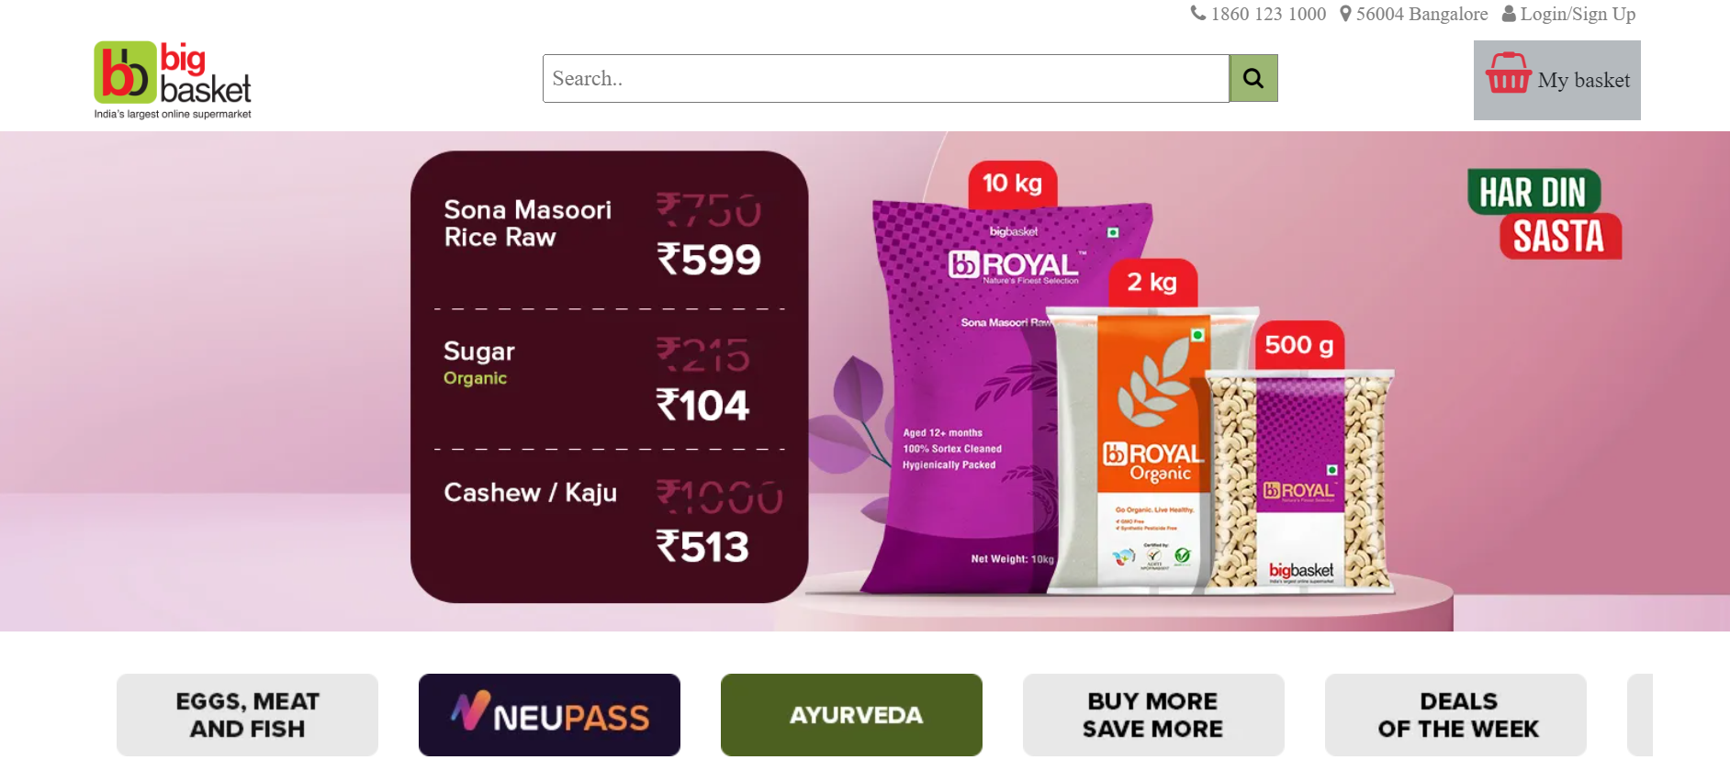

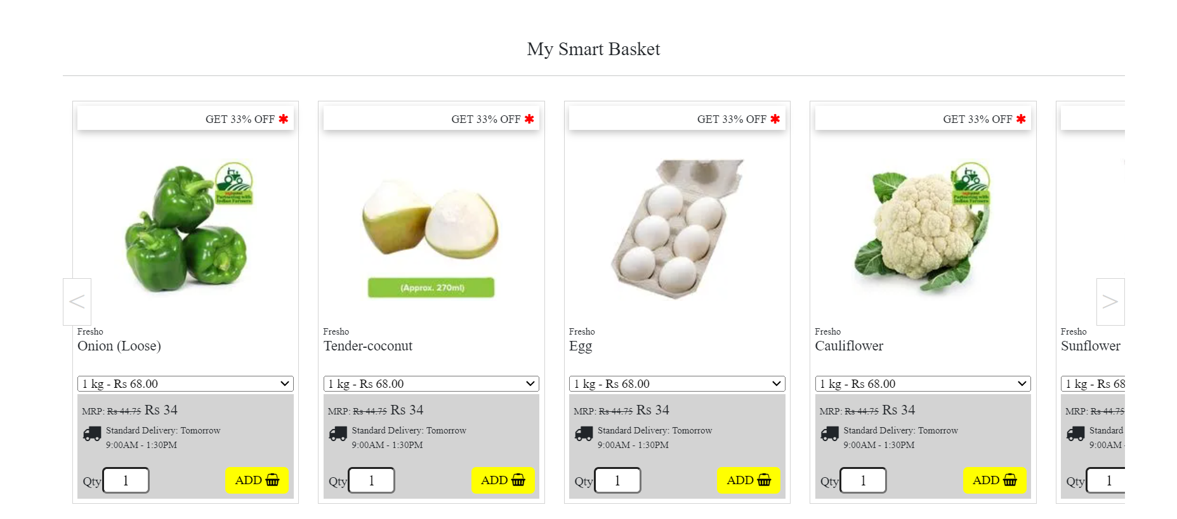

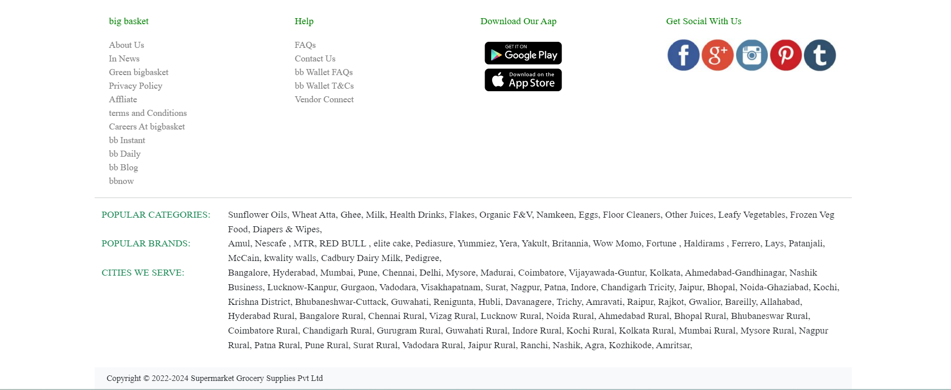

1. **product.html:**

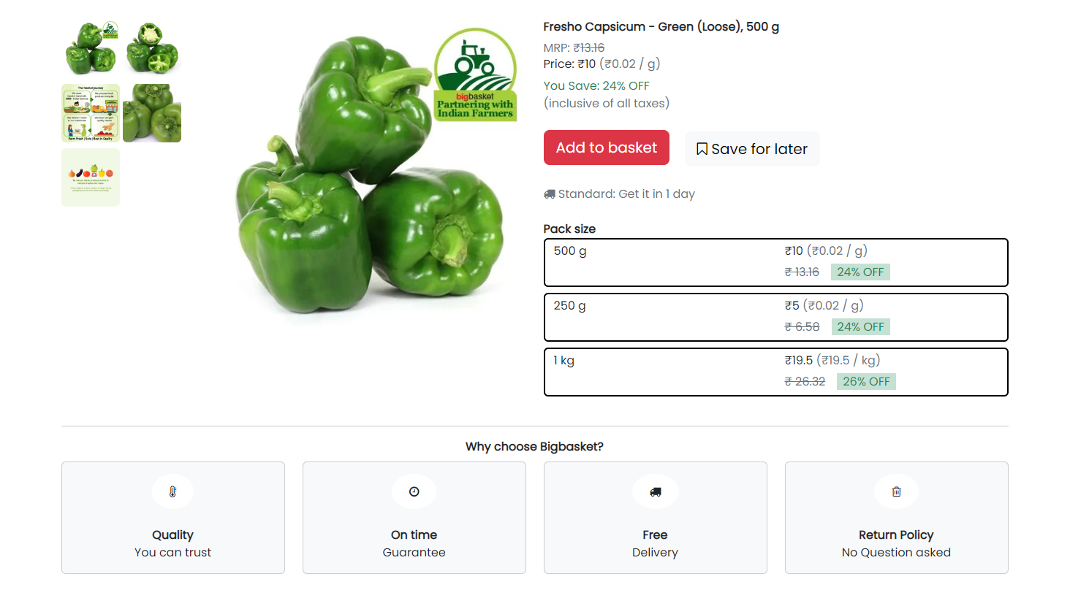

1. **greenbasket.html:**

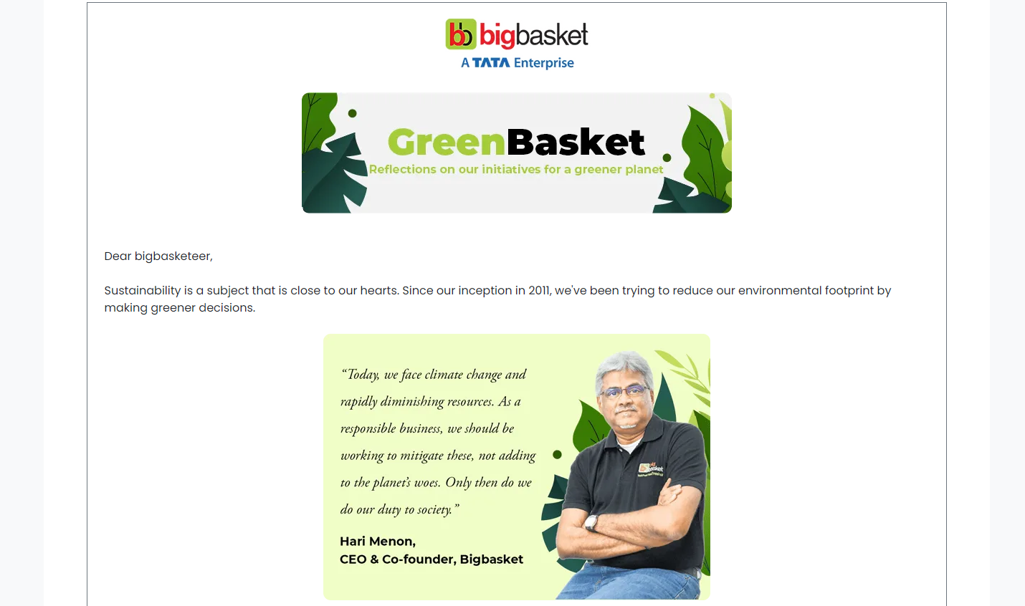

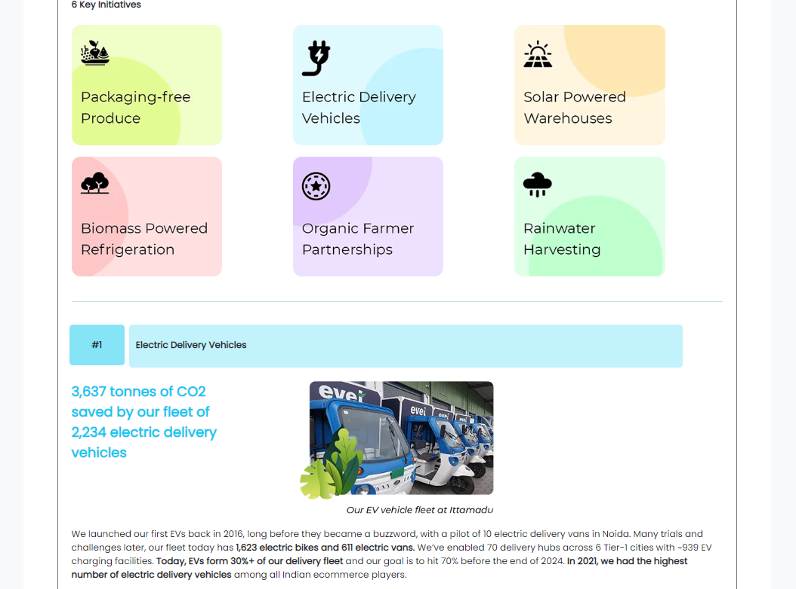

1. **about.html:**

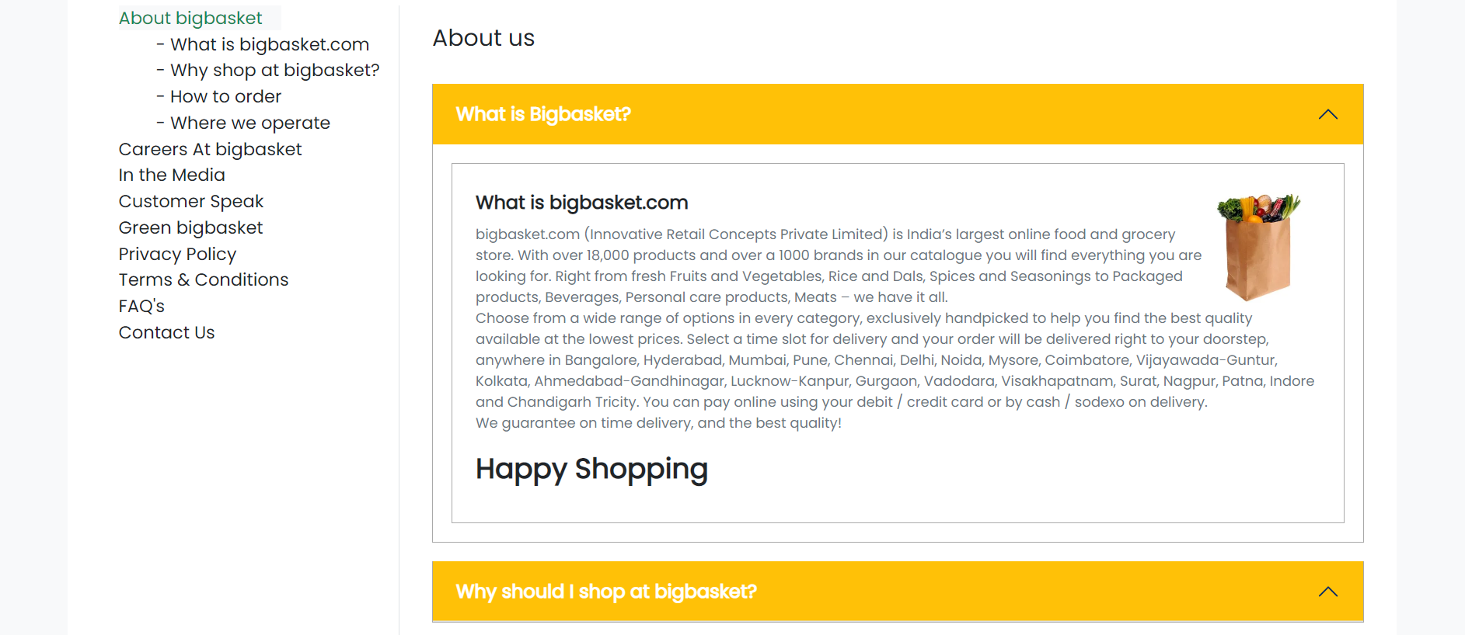

1. **contact.html:**

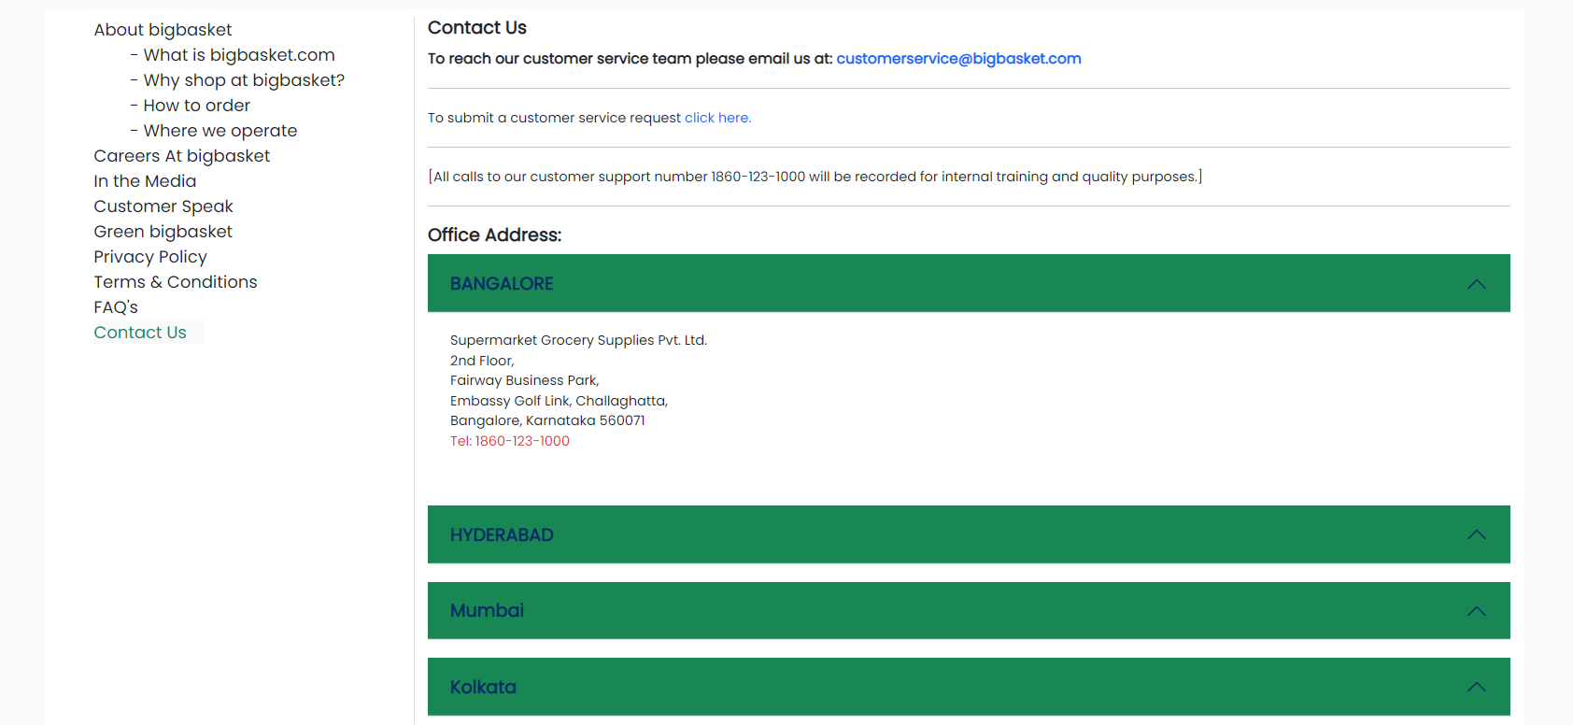

1. **login.html:**

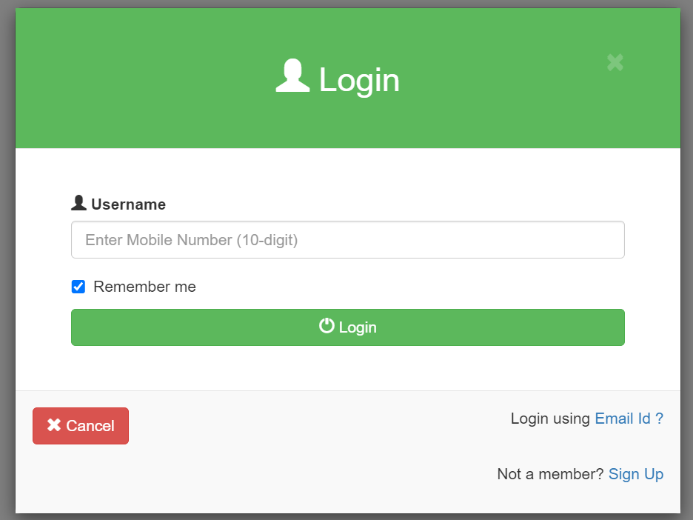

**TESTING**

Software testing is performed to verify that the completed software package functions according to the expectations defined by the requirements/specifications. The overall objective is not to find every software bug that exists but to uncover situations that could negatively impact the customer, usability and/or maintainability.

**PURPOSE OF TESTING**

* Finding defects that may get created by the programmer while developing the software.
* To prevent defects.
* To make sure that the end result meets the business and user requirements.
* To ensure that it satisfies the BRS that is Business Requirement Specification and SRS that is System Requirement Specifications.
* To gain the confidence of the customers by providing them with a quality product.

**TYPES OF TESTING**

There are two types of testing. They are:

1. White Box Testing

2. Black Box Testing

**WHITE BOX TESTING**

**It is a software testing method in which the internal structure/design/implementation of the item being tested is known to the tester. The tester chooses inputs to exercise paths through the code and determines the appropriate outputs. Programming know-how and implementation knowledge are essential. This method is named so because the software program, in the eyes of the tester, is like a white/transparent box; inside which one clearly sees. Internal software and code working should be known for this type of testing. Tests are based on coverage of code statements, branches, paths, and conditions. Also known as structural testing and Glass box Testing.**

**BLACK BOX TESTING**

Internal system design is not considered in this type of testing. Tests are based on requirements and functionality. This method is named so because the software program, in the eyes of the tester, is like a black box; inside which one cannot see. Black box testing is a testing technique that ignores the internal mechanism of the system and focuses on the output generated against any input and execution of the system. It is also called functional testing.

**LEVELS OF TESTING**

There are four **levels of software testing.**

**1. UNIT TESTING**

**Unit Testing is a level of the software testing process where individual units/components of a software/system are tested. The purpose is to validate that each unit of the software performs as designed.**

**2. INTEGRATION TESTING**

Integration Testing is a level of the software testing process where individual units are combined and tested as a group. The purpose of this level of testing is to expose faults in the interaction between integrated units.

**3. SYSTEM TESTING**

System Testing is a level of the software testing process where a complete, integrated system/software is tested. The purpose of this test is to evaluate the system’s compliance with the specified requirements.

System Testing is a level of the software testing process where a complete, integrated system/software is tested. The purpose of this test is to evaluate the system’s compliance with the specified requirements.

**4. ACCEPTANCE TESTING**

Acceptance Testing is a level of the software testing process where a system is tested for acceptability. The purpose of this test is to evaluate the system’s compliance with the business requirements and assess whether it is acceptable for delivery.

Acceptance testing or User Acceptance Testing (UAT) is a level of the software testing process where a system is tested for acceptability. The purpose of this test is to evaluate the system’s compliance with the business requirements and assess whether it is acceptable for delivery.

User Acceptance Testing (UAT) is performed by Users or on behalf of the users to ensure that the Software functions in accordance with the Business Requirement Document. UAT focuses on the following aspects:

* All functional requirements are satisfied.
* All performance requirements are achieved.
* Other requirements like transportability, compatibility, error recovery etc. are satisfied.
* Acceptance criteria specified by the user is met.

**REGRESSION TESTING**

The purpose of regression testing is to confirm that a recent program or code change has not adversely affected existing features. Regression testing is nothing but full or partial selection of already executed test cases which are re-executed to ensure existing functionalities work fine. This testing is done to make sure that new code changes should not have side effects on the existing functionalities. It ensures that old code still works once the new code changes are done.

Regression testing is the process of testing changes to computer programs to make sure that the older programming still works with the new changes. Regression testing is a normal part of the program development process and, in larger companies, is done by code testing specialists. Test department coders develop code test scenarios and exercises that will test new units of code after they have been written. These test cases form what becomes the test bucket. Before a new version of a software product is released, the old test cases are run against the new version to make sure that all the old capabilities still work. The reason they might not work is because changing or adding new code to a program can easily introduce errors into code that is not intended to be changed.

**IMPLEMENTATION**

This application is implemented using HTML, CSS, Javascript language.programming is an approach that provides a way of modularizing programs by creating partitioned memory areas for both data and functions that can be used as templates for creating copies of such modules on demand.

**CONCLUSION AND FUTURE ENHANCEMENT**

**Conclusion:**

It is not easy competing with the market leader when your opponent is Amazon and Flipkart, the largest e-commerce retailers in the nation, who come with decades of experience and billions in the pocket. The story of this online marketplace is quite interesting and a story of constant passion and belief.

Today, we are going to discuss the story of an e-commerce platform which delivers over 2.5 lakh orders of food and grocery products across almost all the major cities. The e-commerce platform identified the need of people who want to get the essential items delivered at their doorsteps. They designed an interface that could allow millions of people to select from thousands of products and get them delivered within the next 24 hours in various slots. While creating an operational app and e-commerce, they also curated the [**best brand activation strategies**](https://www.themarcomavenue.com/brand-activation.php) which led to the formation of online people’s favourite online supermarket. Let’s get into the success story of the business which revolutionised the shopping experience of groceries and essential items

**REFERENCE**

* https://www.w3schools.com/html/
* https://www.w3schools.com/css/
* https://www.w3schools.com/js/
* https://getbootstrap.com/docs/5.0/getting-started/introduction/
* https://cdnjs.com/libraries/font-awesome
* https://www.tutorialbrain.com/css_tutorial/css_font_family_list/